**The name of the company:**

**e-rent**

**Motto:**

Your summer house is here

**Names of all team members and IDs:**

1.**Kamronbek Begmatov**

**ID:** u1610103

**Section:** 001

2.**Bekhzod Shaymonov**

**ID:** u1610046

**Section:** 002

3.**Malika Juraeva**

**ID:** u1610135

**Section:** 002

4.**Aziz Abdulkhakov**

**ID:** u1610035

**Section:** 002

5.**Bekhzodxuja Shavkatov**

**ID:** u1610048

**Section:** 003

**LINK TO GITHUB REPO:**

https://github.com/iuthub/design-project-4shots

**LINK TO WEB SITE:**

<https://erent.urmebel.uz>

The description of the company:

The company called “e-rent” provides services for those, who wants easily and quickly to find and rent summer house(dacha) and also for those, who has cottages and would like to announce their country house worldwide, so to pick up customers for making business (profit).

As day by day more and more people are going to countryside to have a rest, and as there are too many dachas, it became a problem for people to find summer cottage best suiting them and as there is no guarantee that they won’t be fooled by fake photos or fake description of conveniences of dachas, the main purpose of the e-rent became to help those folks.

E-rent has 5 web-developers, who maintain the web site. 2 guys watch for the front-end, and 3 back-end programmers support the database.

Screenshots for each feature

Kamronbek Begmatov, u1610103

* **Sign-up page**

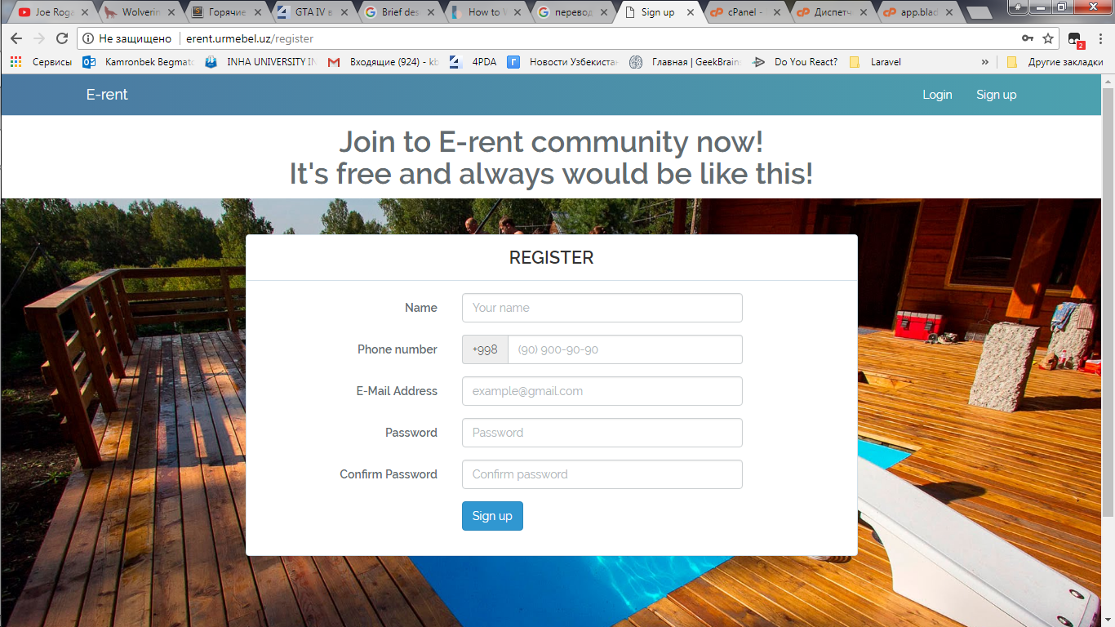

Anyone may register by just filling input fields shown above.

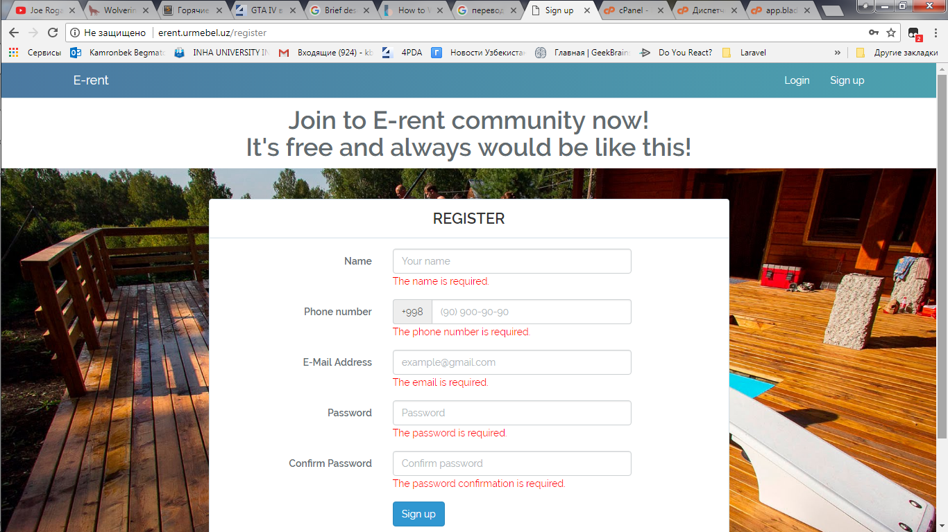

There is a **client-side validation** in sign-up page. It was implemented by including “src=<https://ajax.googleapis.com/ajax/libs/angularjs/1.6.9/angular.min.js>” and using angular-js itself and regular expressions (not the framework, you allowed us to use angular for validation). If you don’t fill, skip any of input fields, or jump to next input field, right away, in real time browser will show you messages that those input fields are required.

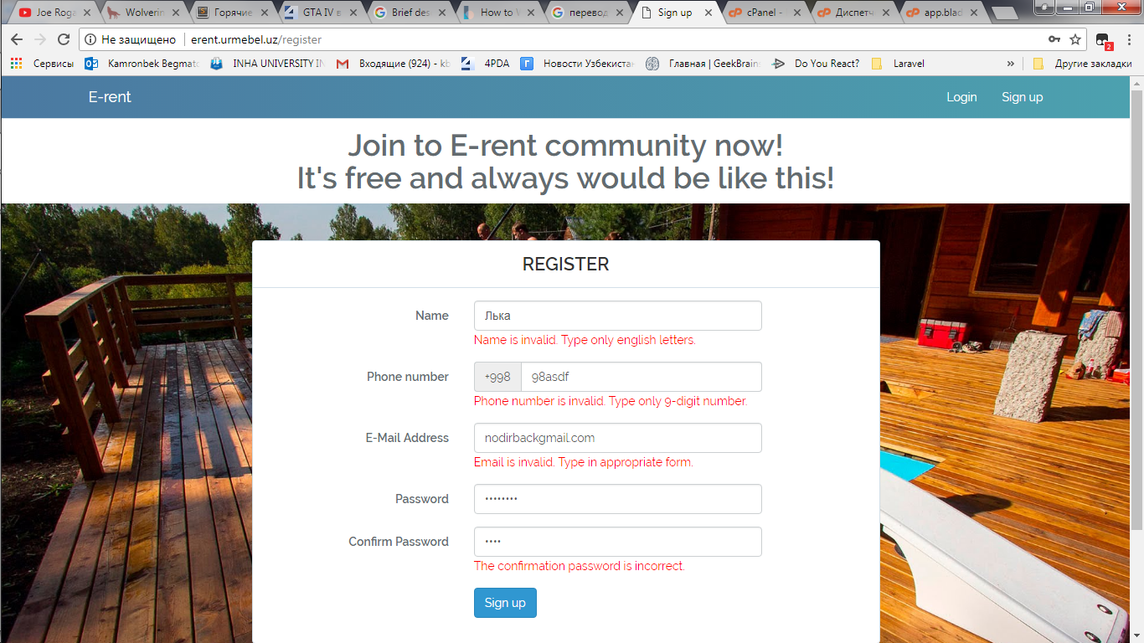

Furthermore, appropriate error messages will be shown:

* if you type numbers or non-English letters in name field
* if you type letters or not 9-digit number in phone number field
* if you type email in inappropriate form (miss ‘@’ or ‘.’)
* if you type password, which length’s is less than 6, and if confirmation password doesn’t match the password.

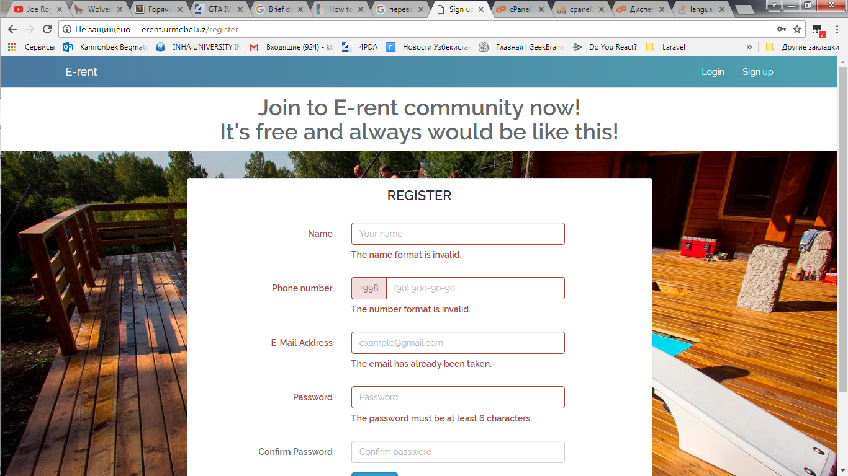

Surely there is server-side validation, checks the data after clicking submit button, by special function, which uses regular expression as well, and shows error messages (same as mentioned before, just like in client-side validation).

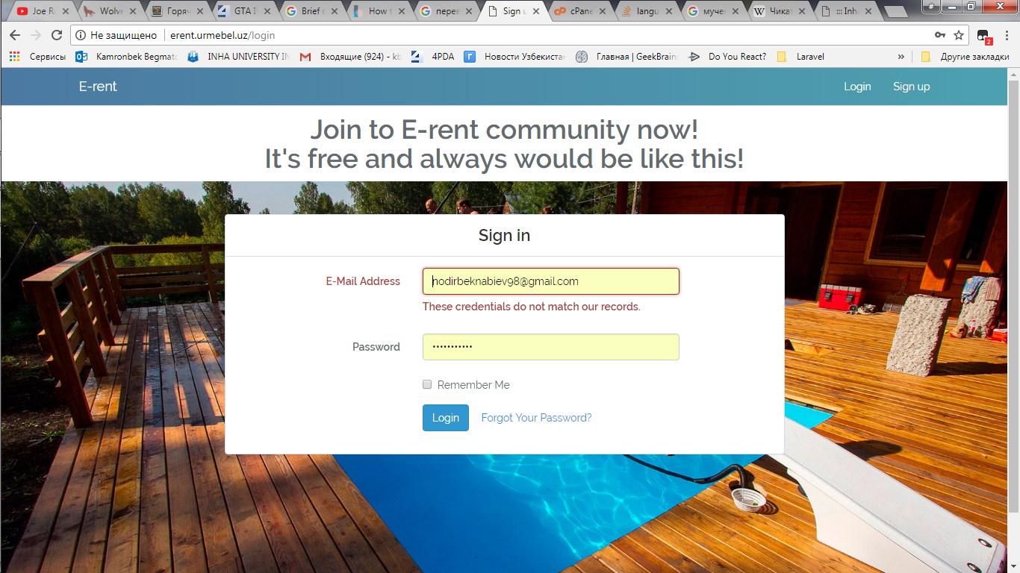

* **Sign-up page**

The same (functionality) as Sign up page.

Bekhzod Shaymonov, u1610046:

Contacts us:

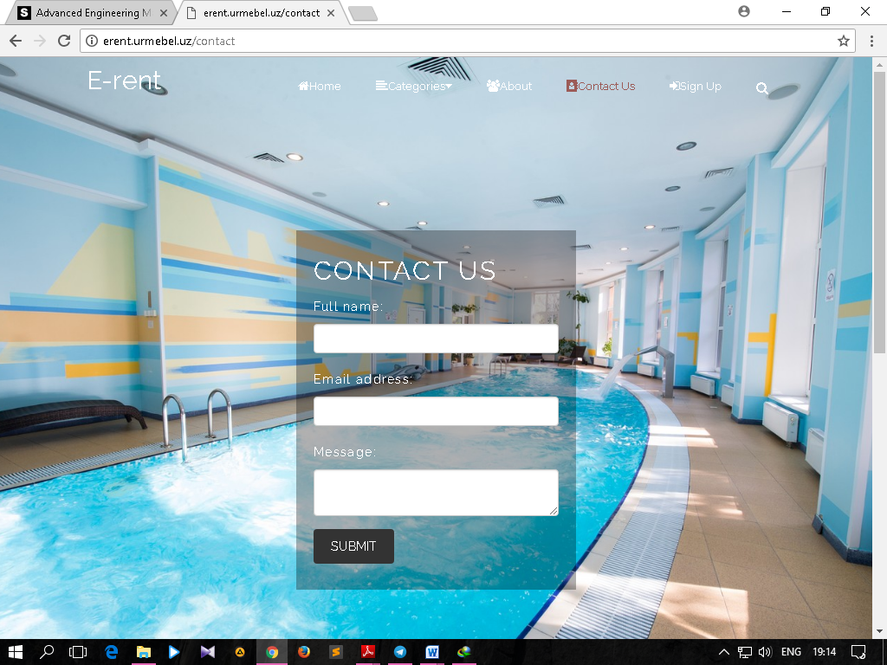

The aim of this page is if user has any feedbacks or questions, may ask by just entering his/her full name, email address and message (feedback/question).

Of course, it has some validations:

If user leaves any blank it shows error message:

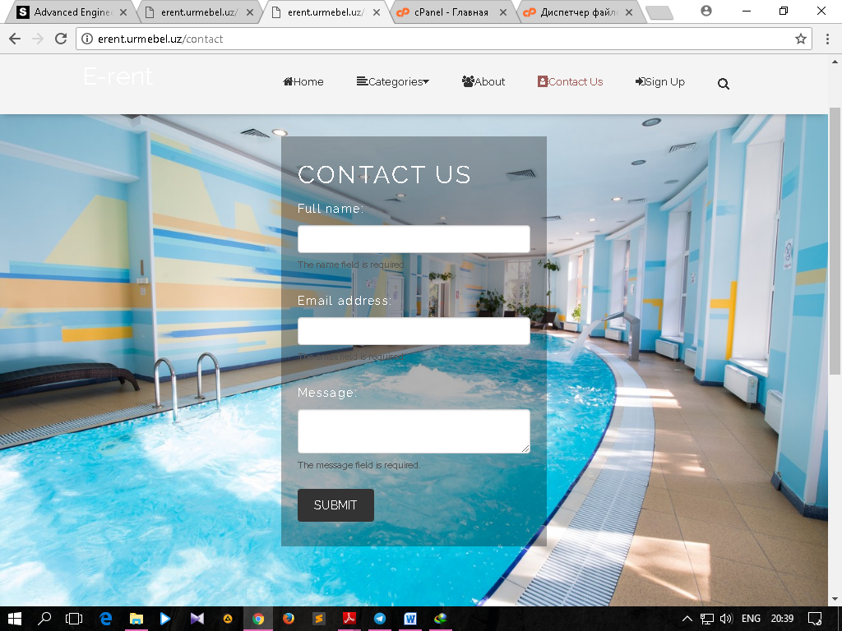

If user enters something else in E-mail address, it shows error message:

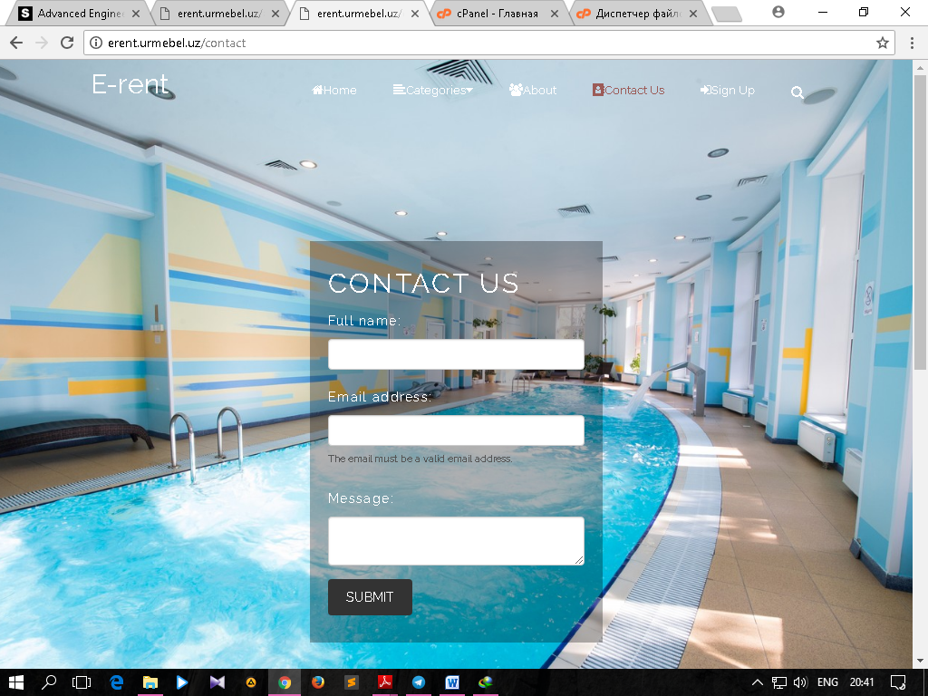

If user does everything correctly and clicks the submit button, it shows that message successfully sent:

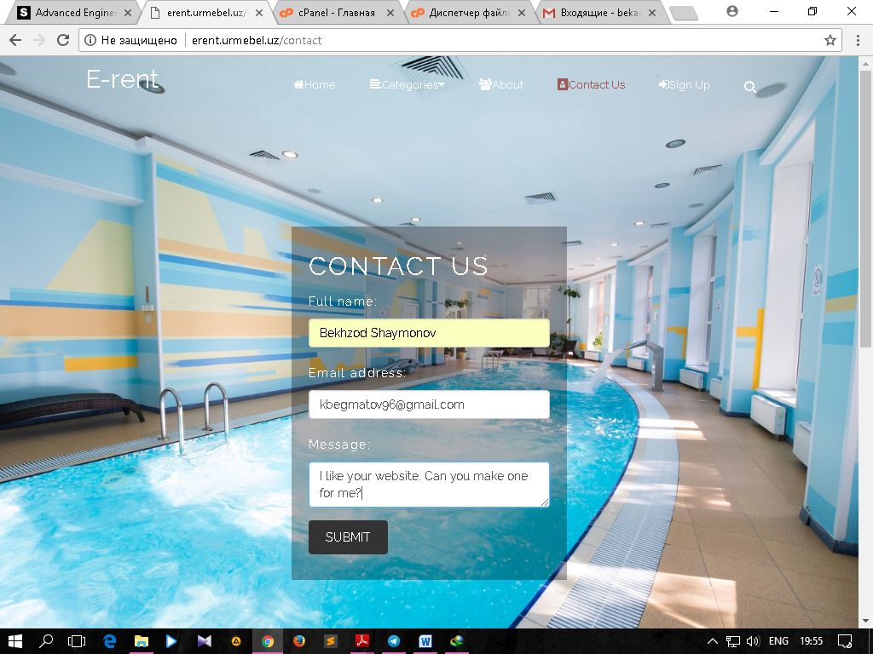

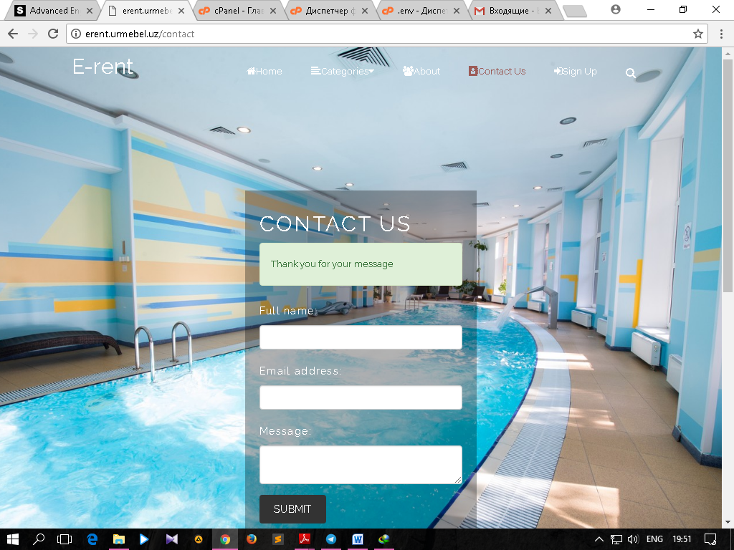

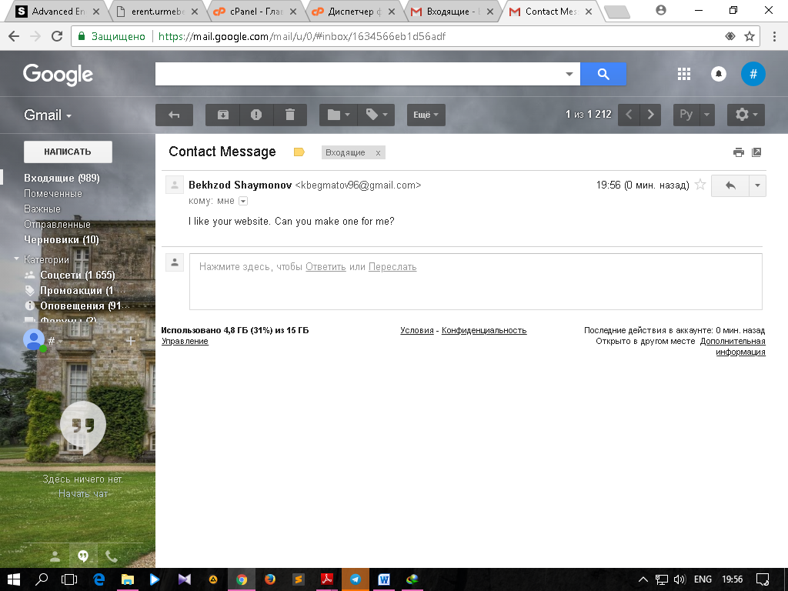

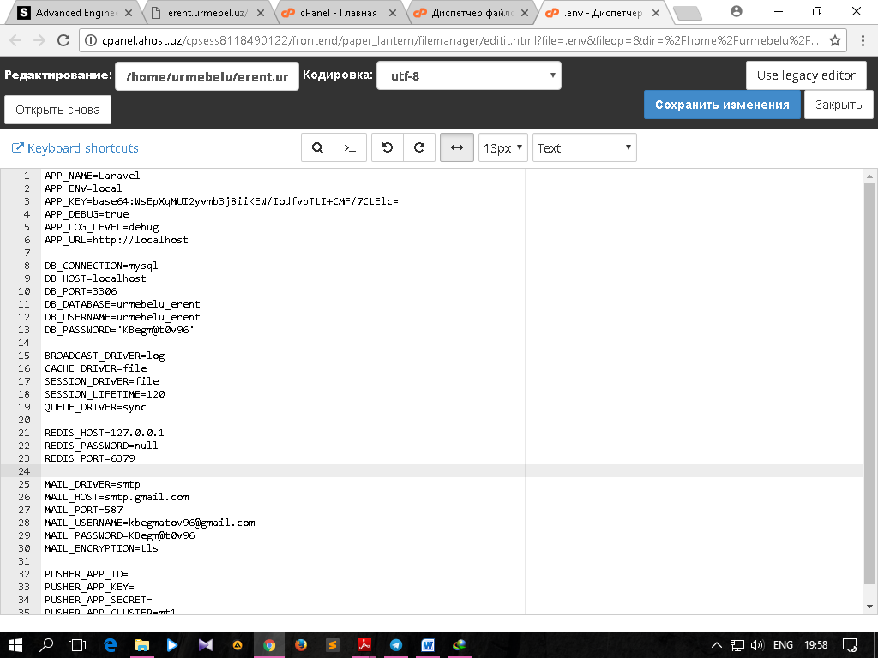

External web service

We included google maps of INHA in our web-page. In order to make it work I had to generate API key through my gmail account. The take that generated key put it the code and set longitude and latitude:

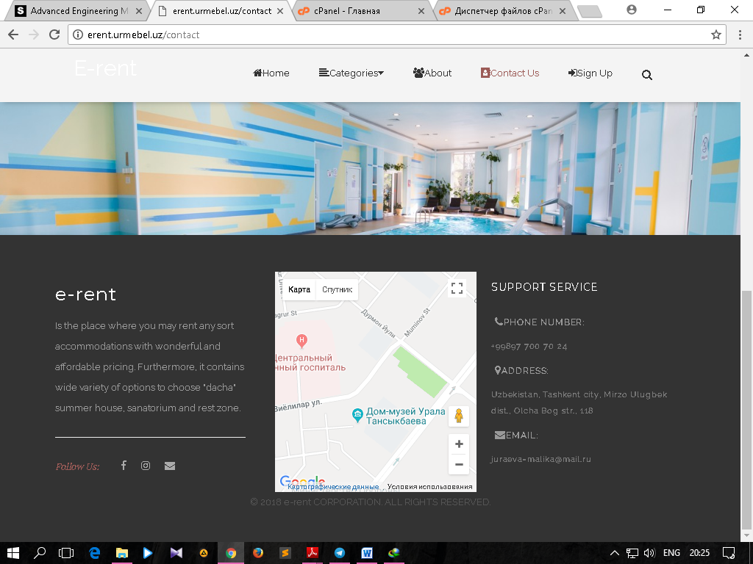

Supporting Front-end:

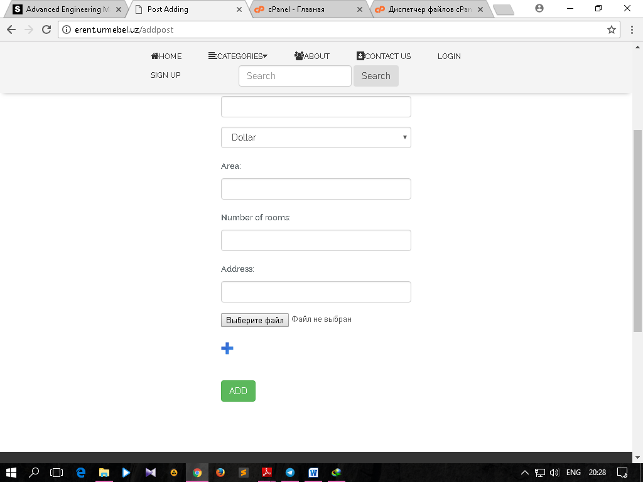

When a user wants to rent accommodation, he/she should have choice of to post one or more images.

To look appropriate, I included “plus” image, so when user wants more to upload he/she needs to click it:

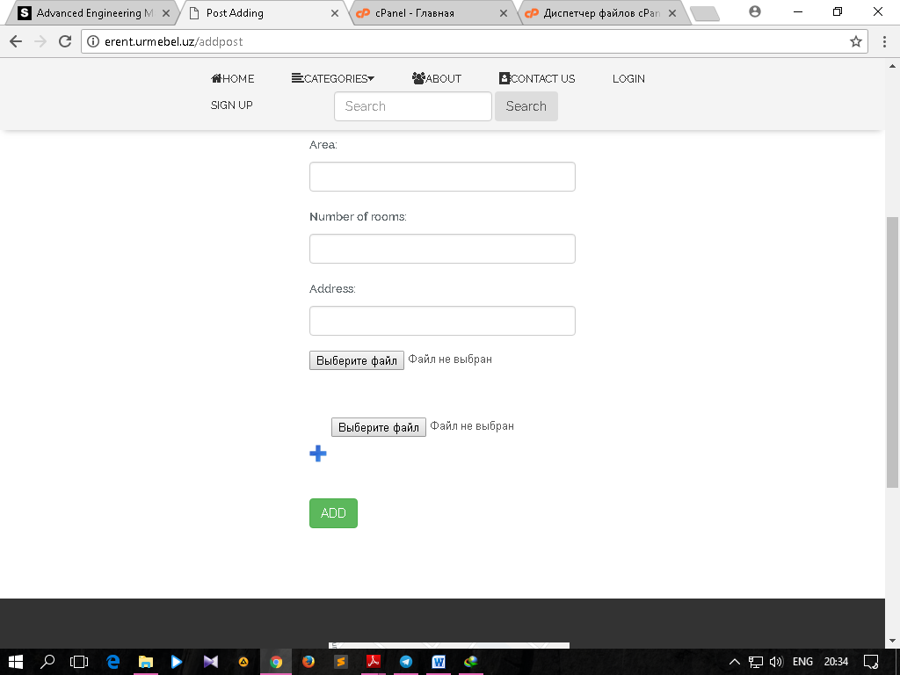

However, I limited it to 10 because 10 is more than enough.

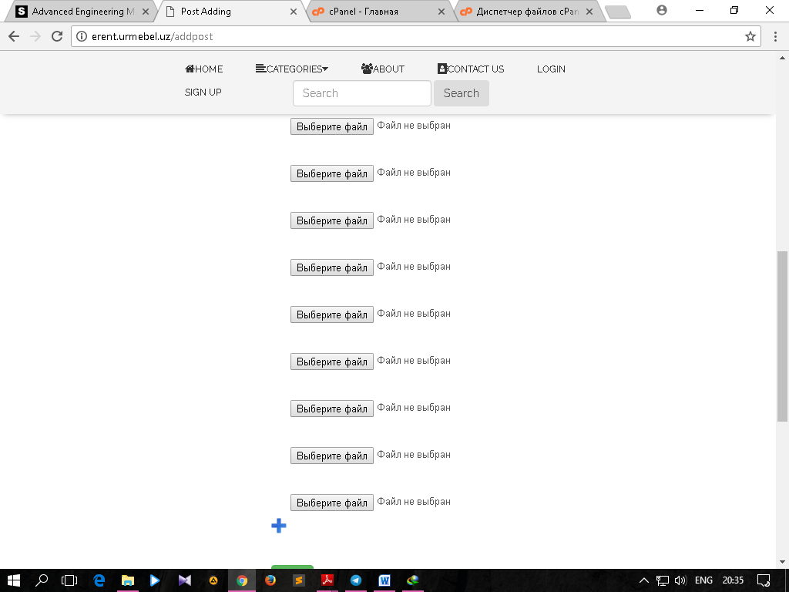

I did this by using Javascript.

Aziz Abdulkhakov, u1610035

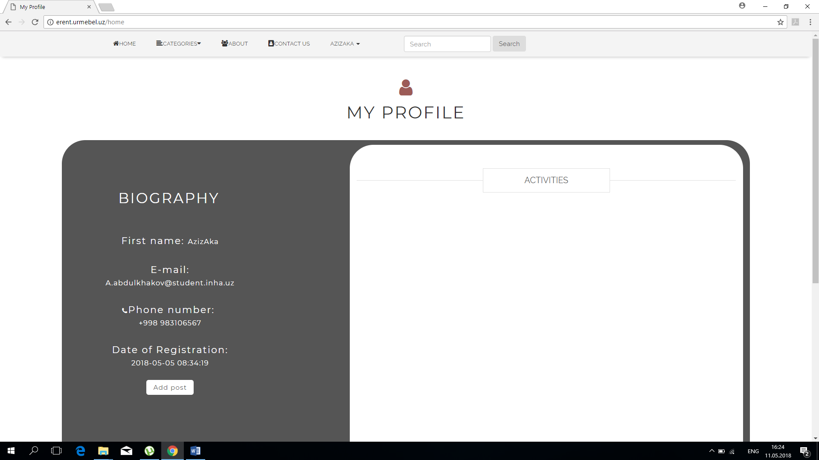

Here is My profile page, which shows your posts and information about you, also this page has ADD POST button, which redirects to page where you can add post.

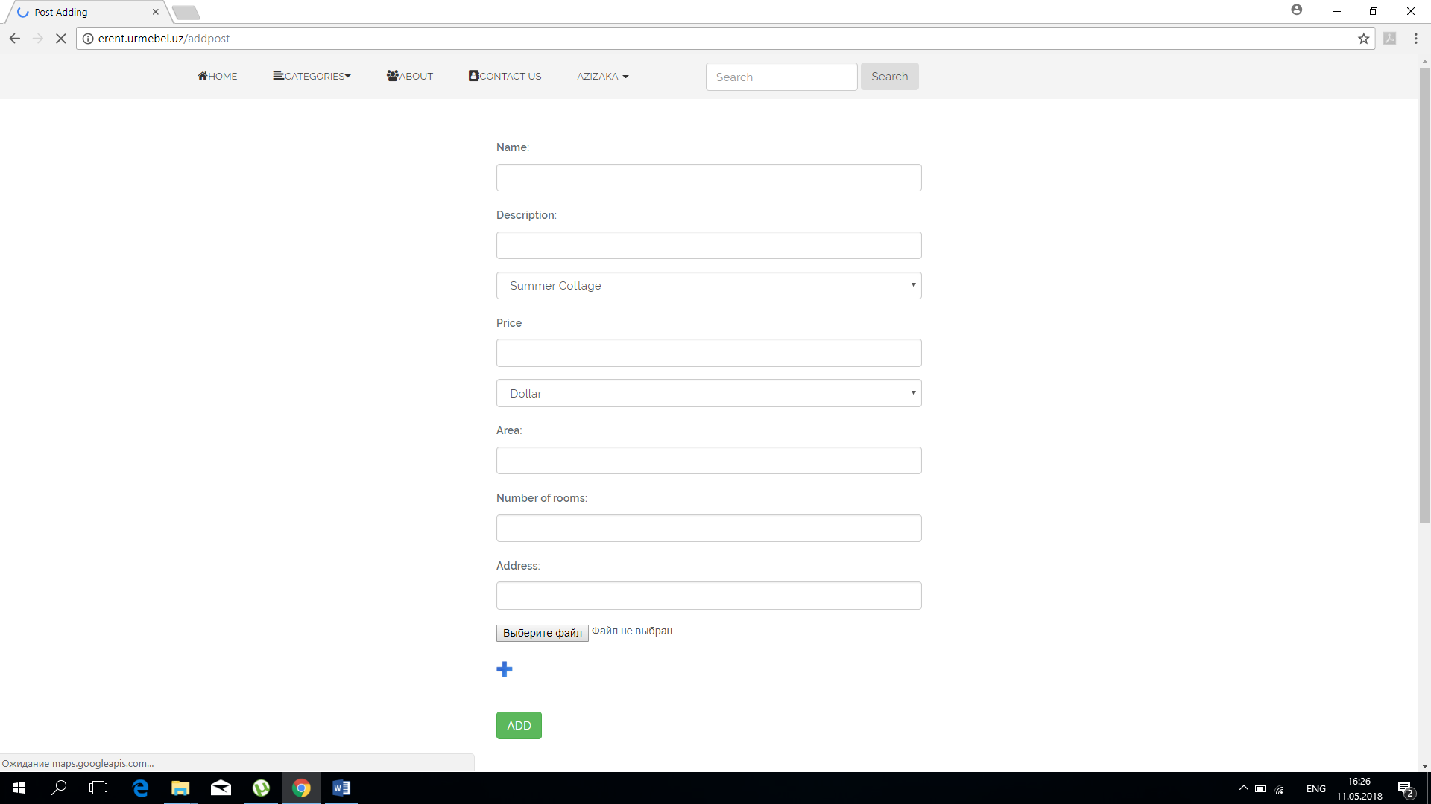

* If you forgot to enter something, it returns the same page with errors.

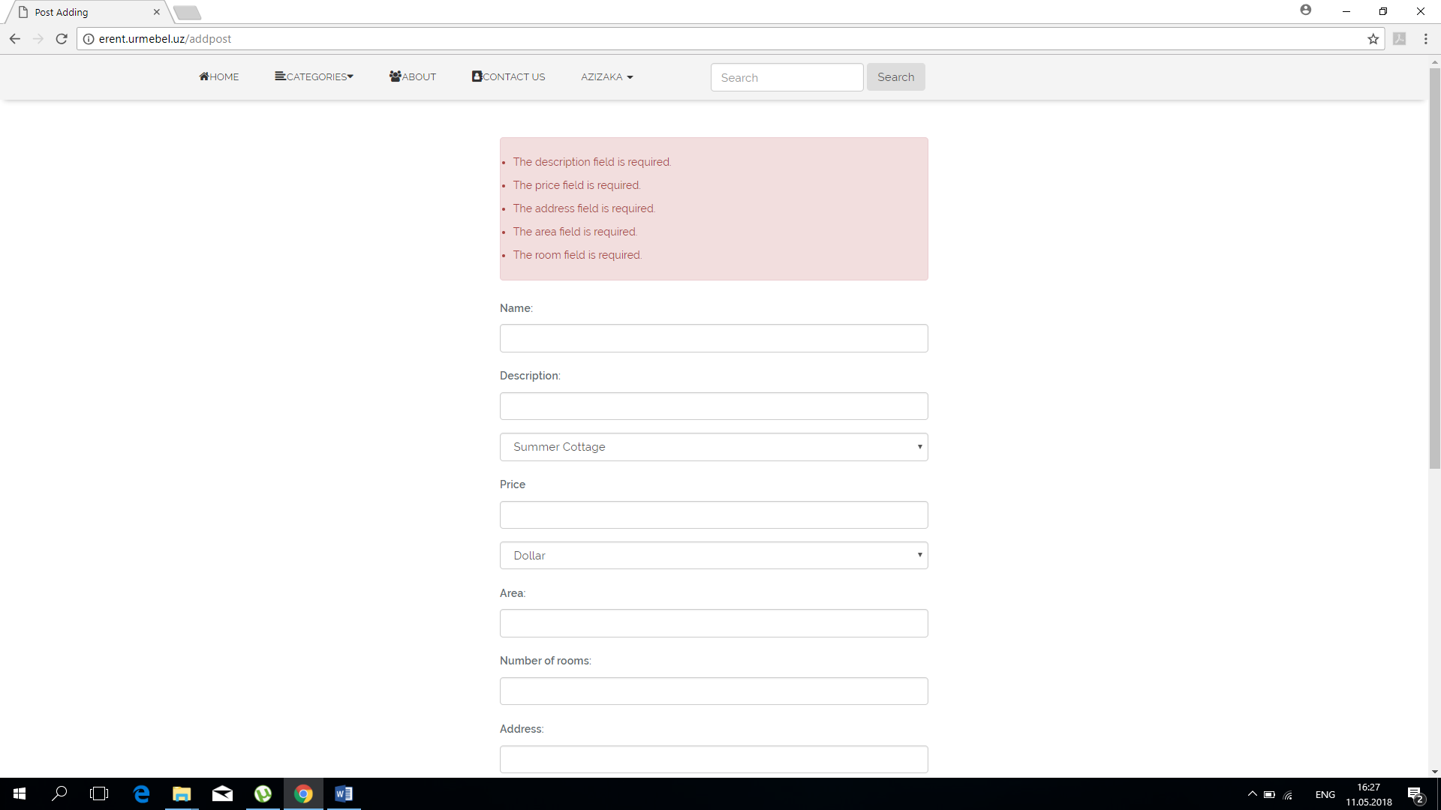

After pressing add button, it routes to posts controller, where all information is processed and inserted into database with Eloquent.

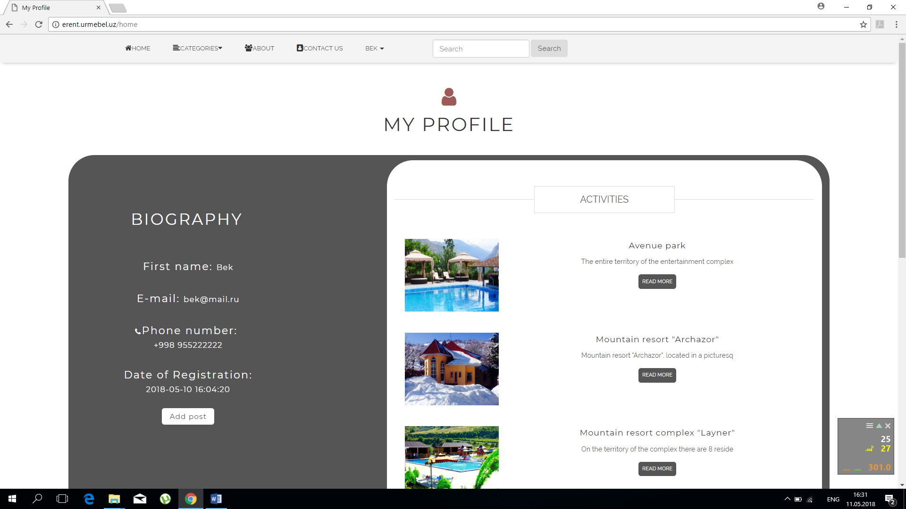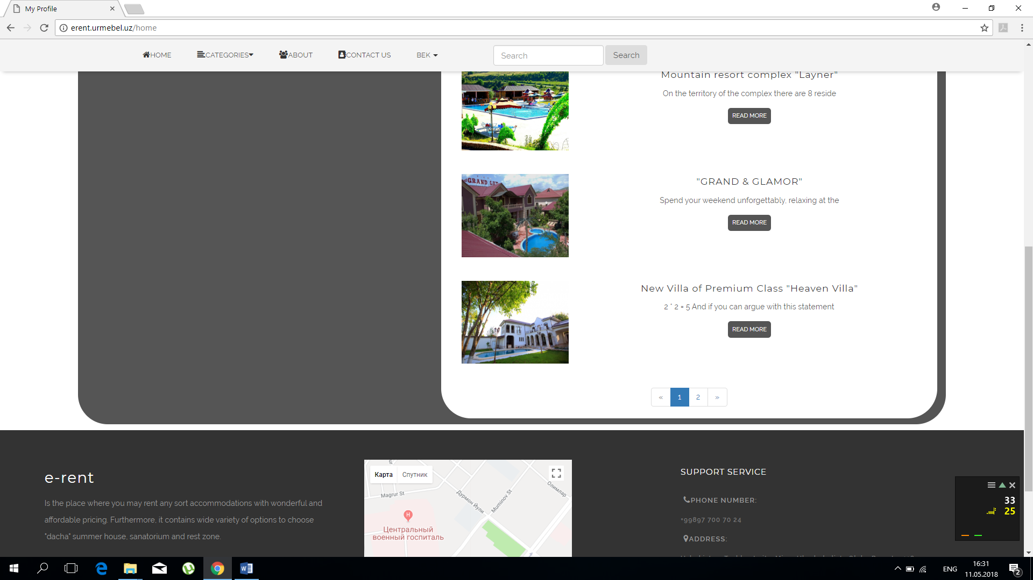

After adding posts. In MY PROFILE page you can see your own posts with links and pagination.

With PostsController and Eloquent, it sorts all posts according to their special attribute USER_ID.

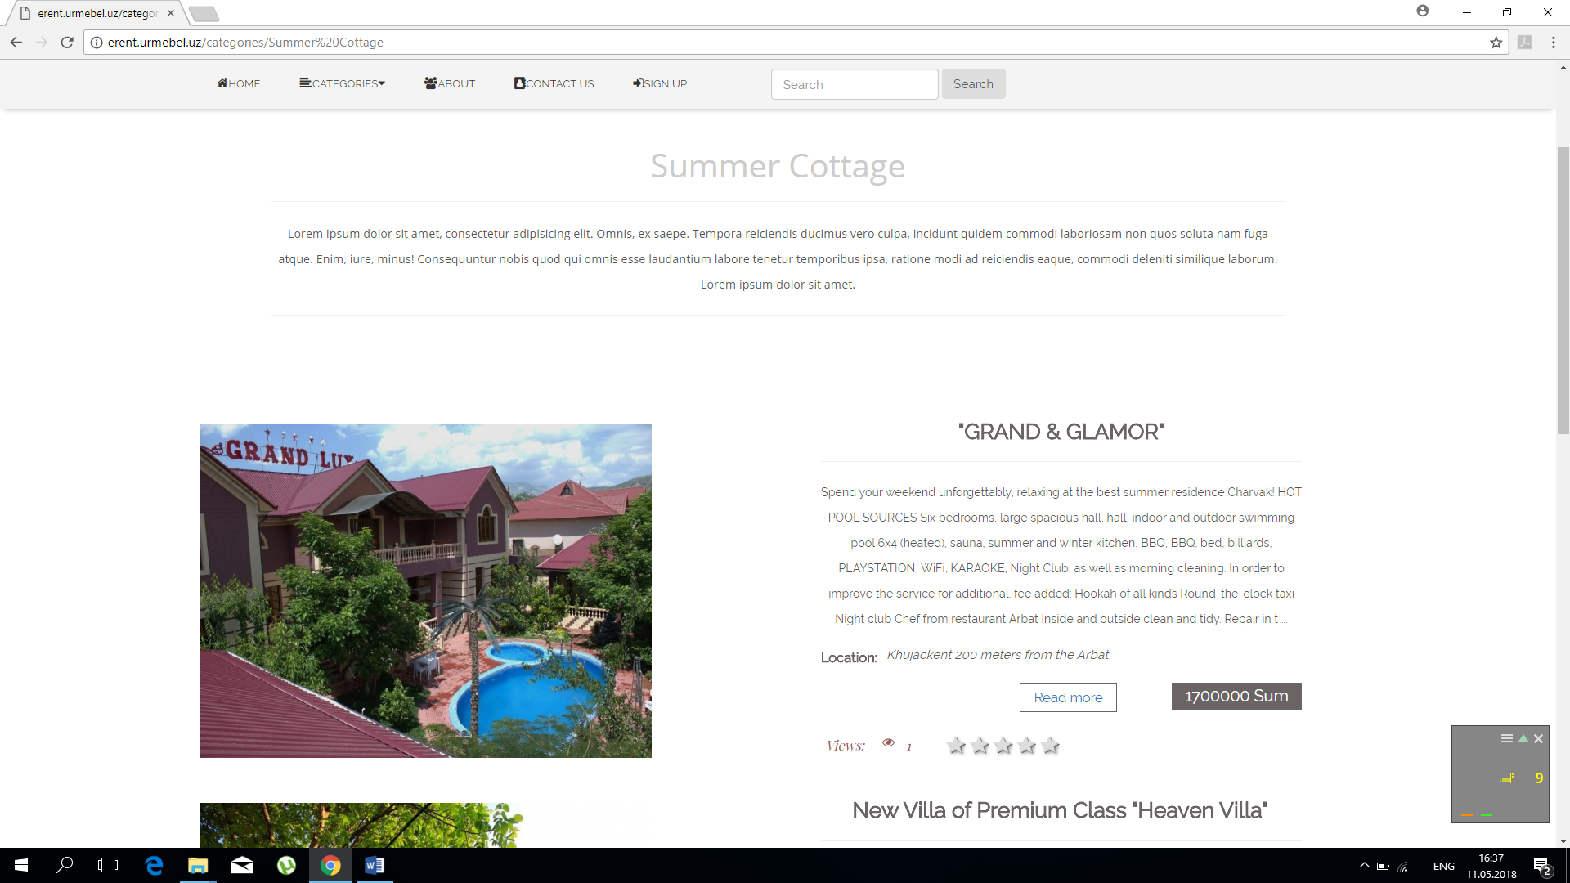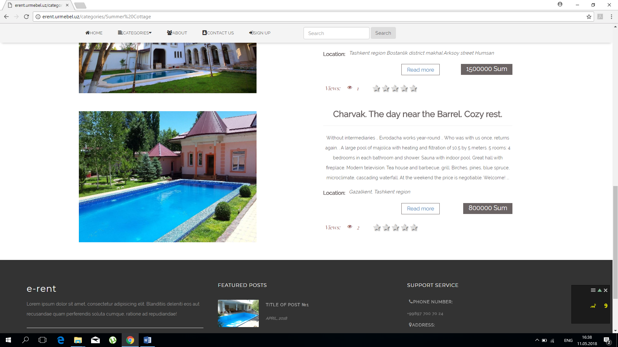

In page categories-> Summer Cottage(or another category)

Controller sends posts which belong to certain category, with links to them and pagination.

In this page, you can be acquainted with short information about announcement.

(Title, short description, location and price)

When you enter to announcement It automatically generates page with certain announcement( with own info(title description photo and etc.))

This page shows full information(full description, title, number of rooms, phone number of user which post this announcement, price and area, also all images which belongs to this announcement)

All this information gets from database using posts controller.

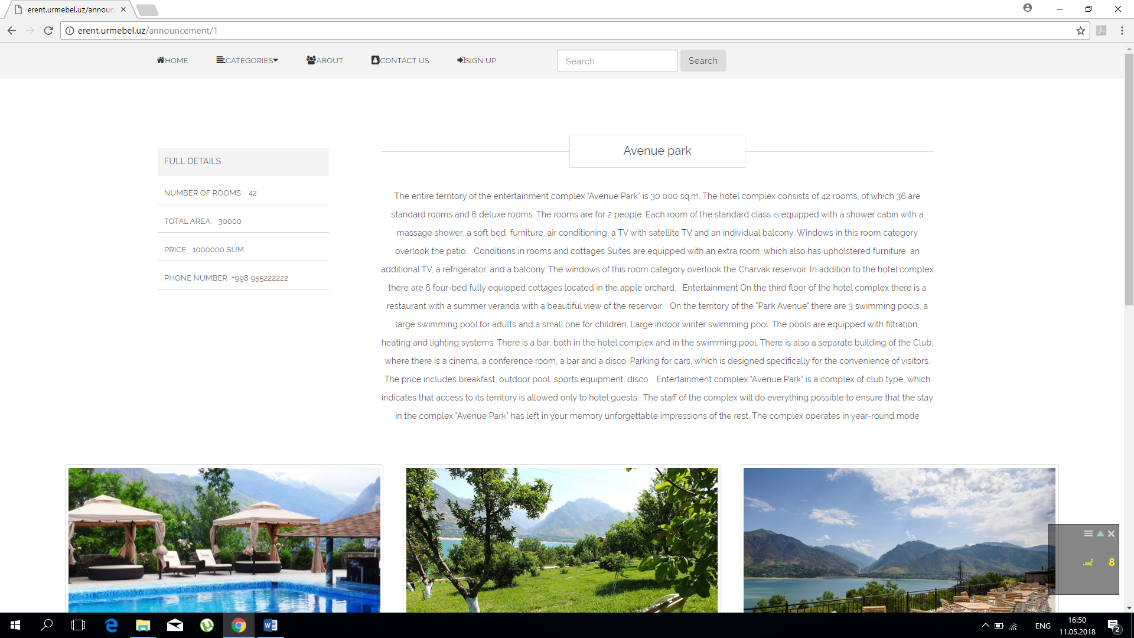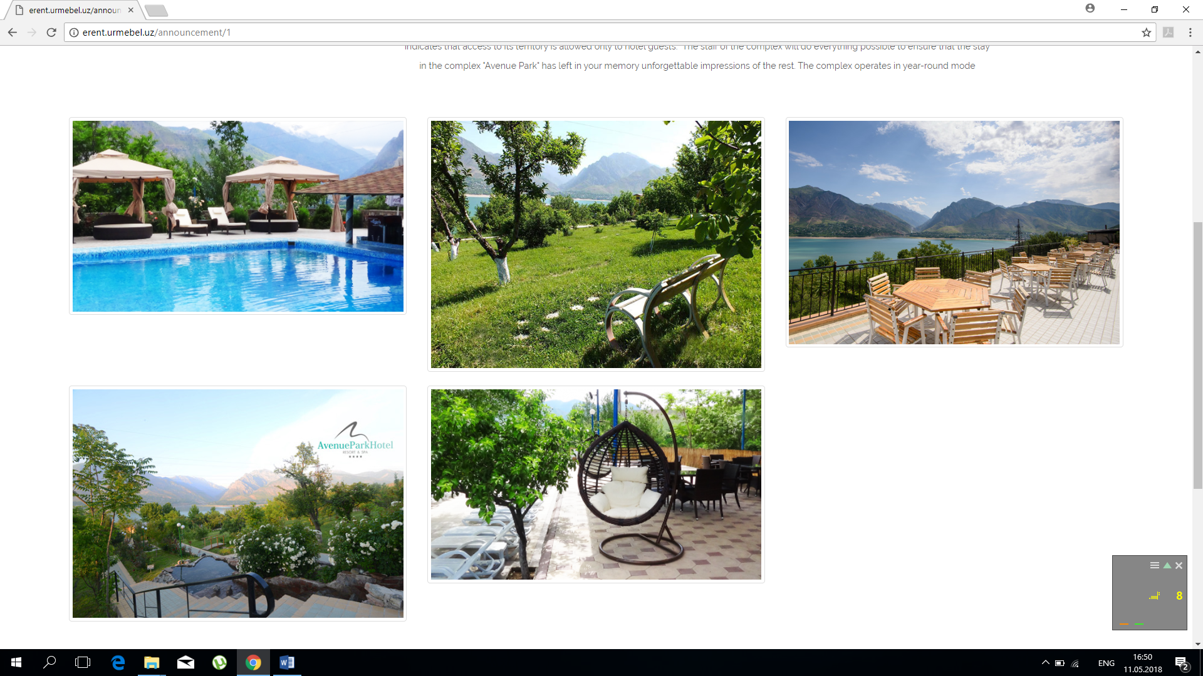

Also after entering certain announcement, number of views automatically will increase.

Also we have Search. You may enter some words and it checks whether the info you want to find, exists or not in website.

For example here I wrote Avenue and it returns announcement with word Avenue.

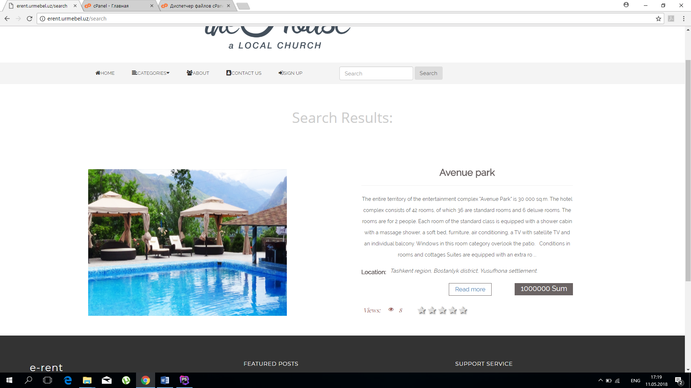

Malika Juraeva, u1610135

I’ve created homepage.css and homepage.js. Here, you can find all css and js codes for all pages of our web site. According to the requirements of the project, I used bootstrap for building elements, JQuery for giving some classes to these elements.

Let’s start with welcome page.

Since my html code is built by parts using sections >div elements, it was easy for me to give styles. Firstly, we can see transparent navigation bar with icons, logo and search icon. To create this navigation bar I didn’t use bootstrap sample, but I created my own. I’ve defined <header> tag and <div>, <ul>tag inside of it. To get ready our navigation bar we need to style it. I’ve mentioned most common ones:

width,height, padding and margin

position:fixed;

text-decoration:none;

background: transparent;

float:left;

list-style: none;

display:inline-block;

-webkit-box-shadow:0px 5px 10px -5px rgba(0, 0, 0, 0.3); // to differ navigation bar from content of web page

In our navbar, there is dropdown category, which defined using <ul> tag. It’s displayed on hover that is why it has display:none; property.

Moreover, there is search bar, which is done using <input> tag. It’s defined in on one block with nav inside of <header> tag in order to make right SlideToggle effect in .click(function){…} using JQuery.

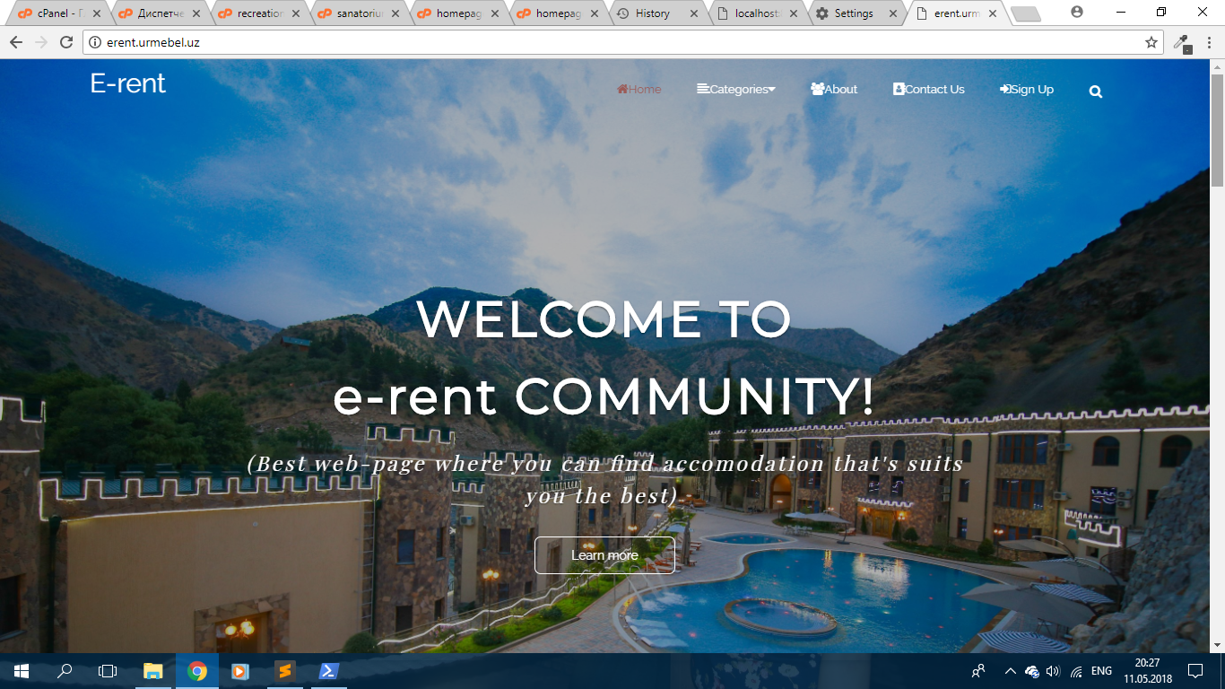

As our navigation bar is transparent to look our carousel better, we need to give a background-color after scrolling. It’s done using JQuery in

$(window).scroll(function(){…}

by adding user defined css classes.

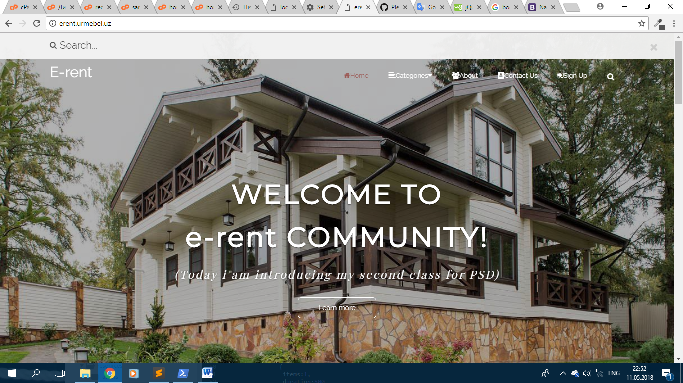

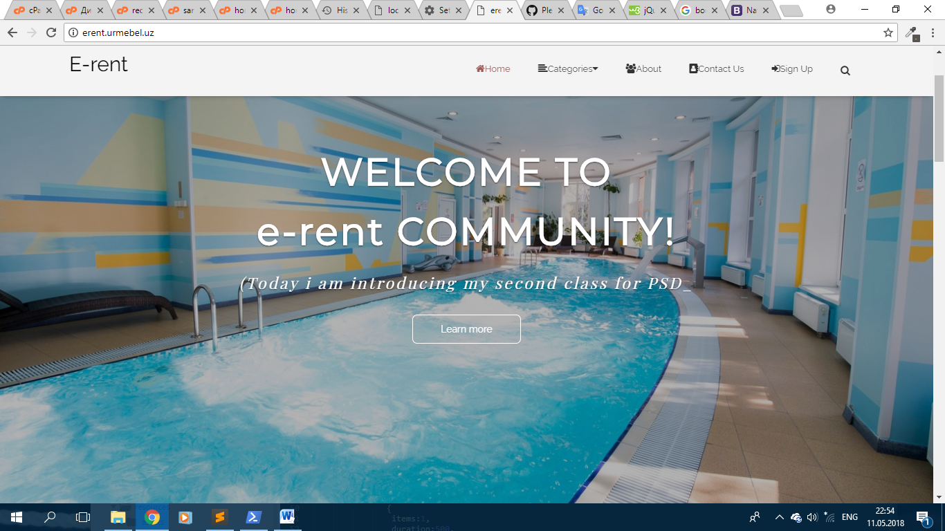

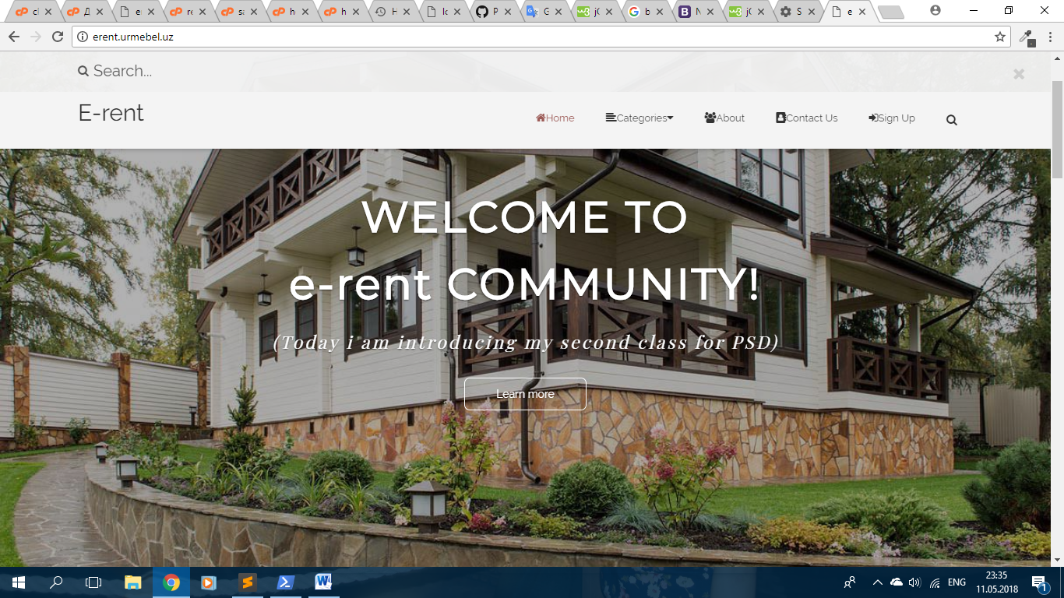

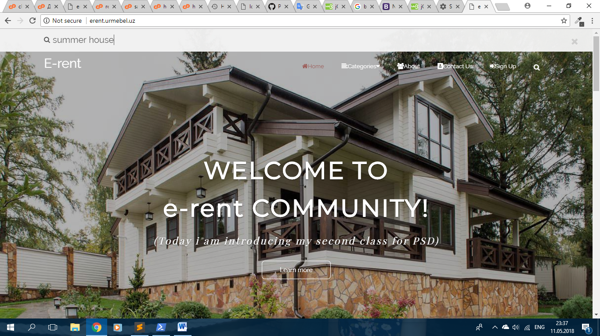

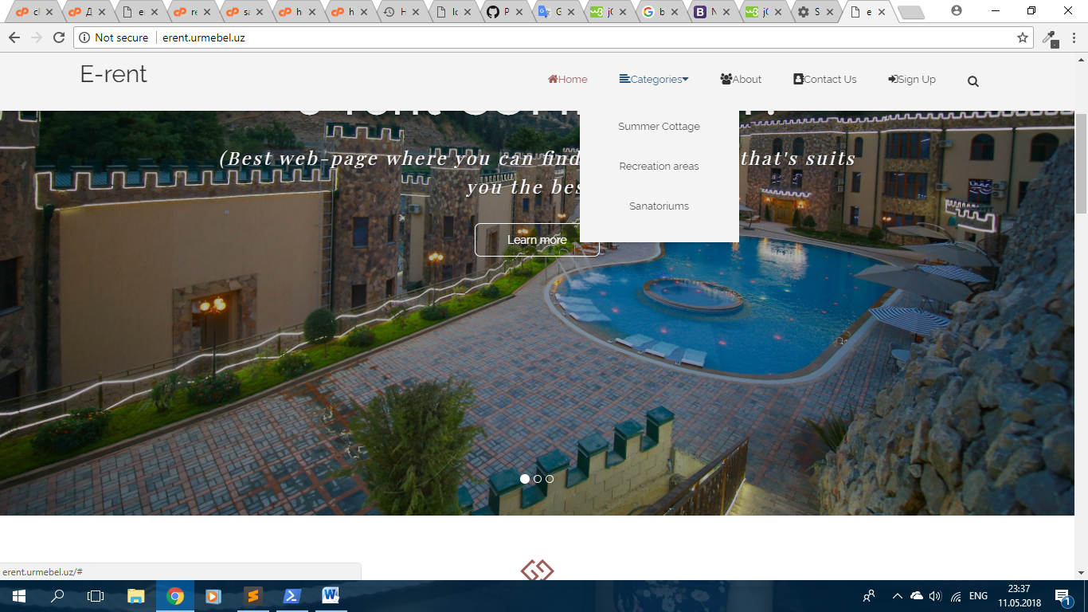

Bootstrap Carousel: I’ve just set for full screen width. Firstly, I’ve deleted carousel navigators ; gave a caption for each slide (background:rgba(0,0,0,0.3); to make darker background picture) and animated them( giving classes: animated, animatedFadeInUp and fadeInUp, which are defined in homepage.css file).

The following part is “Benefits we offer”. Here every client of our web site can get brief information about our services. For most of headings and paragraph which are needed to be centered, I’ve just used bootstrap class=”text-center”. So,

<div class=”container”>

<div class=”row”>

<div class=”col-md-3 col-md-offset-1”>…</div>

<div class=”col-md-3 col-md-offset-1”>…</div>

<div class=”col-md-3 col-md-offset-1”>…</div>

</div>

</div>

Styles to them:

border: 1px solid #555555;

border-radius:10px;

margin, padding, width, heigt

hover effect { transform: scale(1.1); transition: 0.3s ease; }

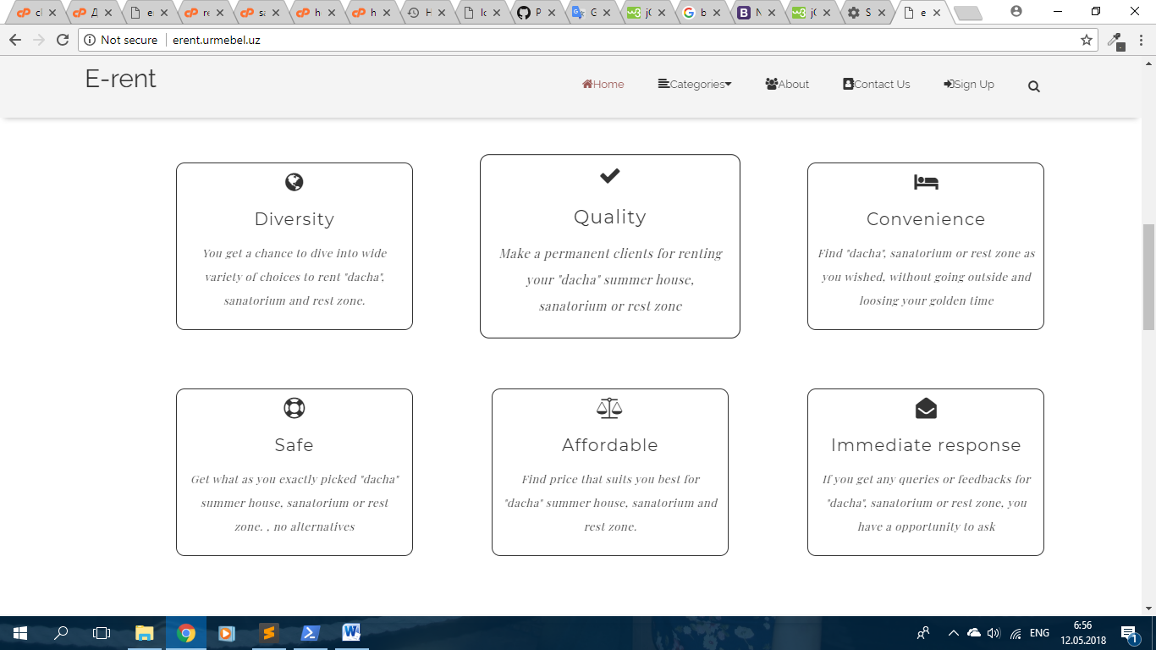

In addition, we have “recently added items” part, which is a small carousel, called jquery.carouFredSel-6.2.1 packed version. I’ve downloaded (located in public/ js/… ) and linked to .blade.php files. To make it work I should give jQuery code. The structure of html code is quite similar to previous one:

<div class="row" >

<ul class="recently-carousel" >

<li>

<div clss="inner-content" >

<img src="…" >

</div>

</li>

<li>

<div clss="inner-content" >

<img src="…" >

</div>

</li>…

</ul>

As you can see, I’ve used “row” bootstrap class with <ul> (has class “recently-carousel” for JQuery selector), <li> tags in it. Also, every image inside of div (has bootstrap class “inner-content” since it is considered as a content part to recently added items) to make easy alignment. Each <di>, <img> element got some styles:

height, width, margin, padding

display: inline; // to make images in one line (since <div> is a block element)

filter: grayscale(100%); // to make black and white image

filter: grayscale(0%); // returns image to original view on hover

Then, we have to give some js to work our carousel:

$('.recently-carousel').carouFredSel({

responsive:true,

width:'100%;',

circular:true, //to slide continuously

scroll:

{

pauseOnHover:true //pause on image hover

},

items:

{

visible:

{

min:1,

max:4 // to slide 4 images at time

},

}

});

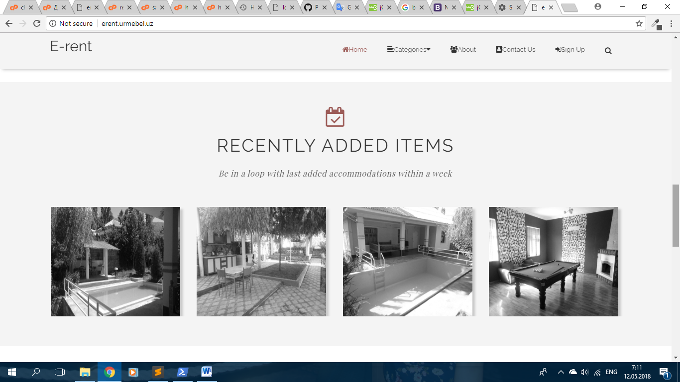

Here, you can see that images slide and hover effect.

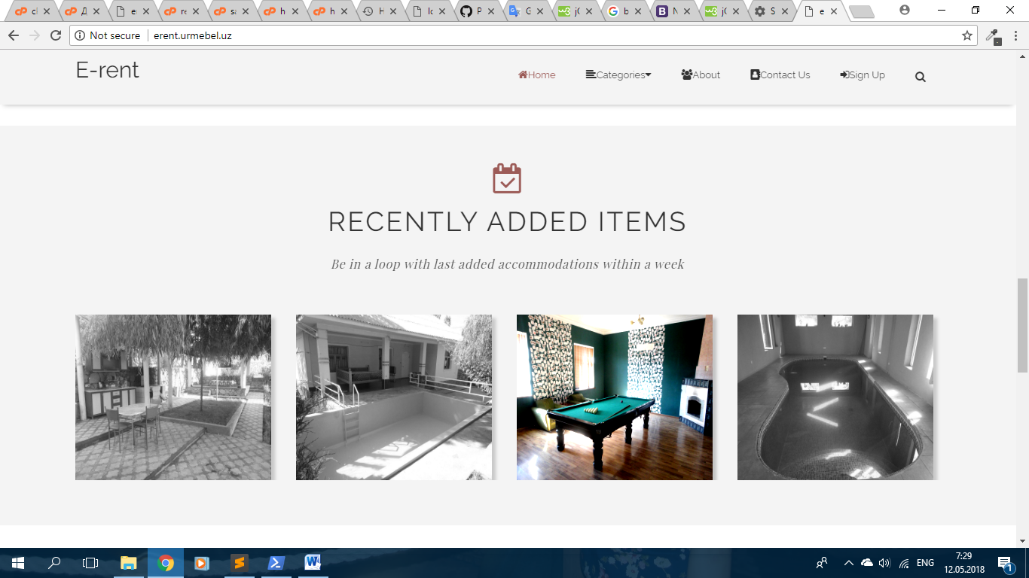

Next, our motto is placed here. As you can see there is cool parallax image with description on the bottom. I’ve made several screenshots to show parallax effect:

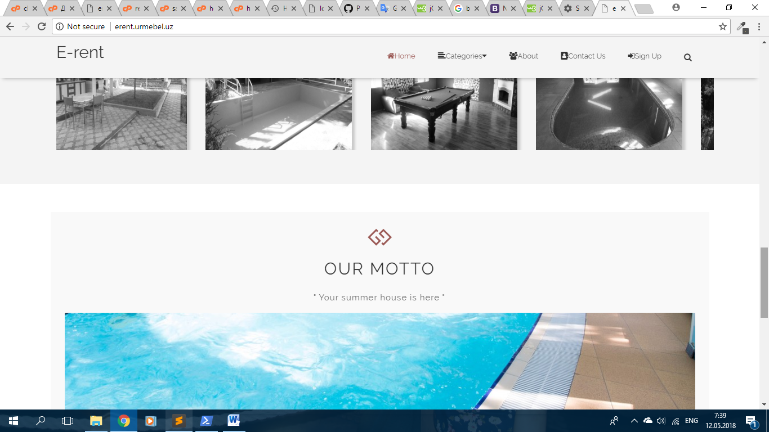

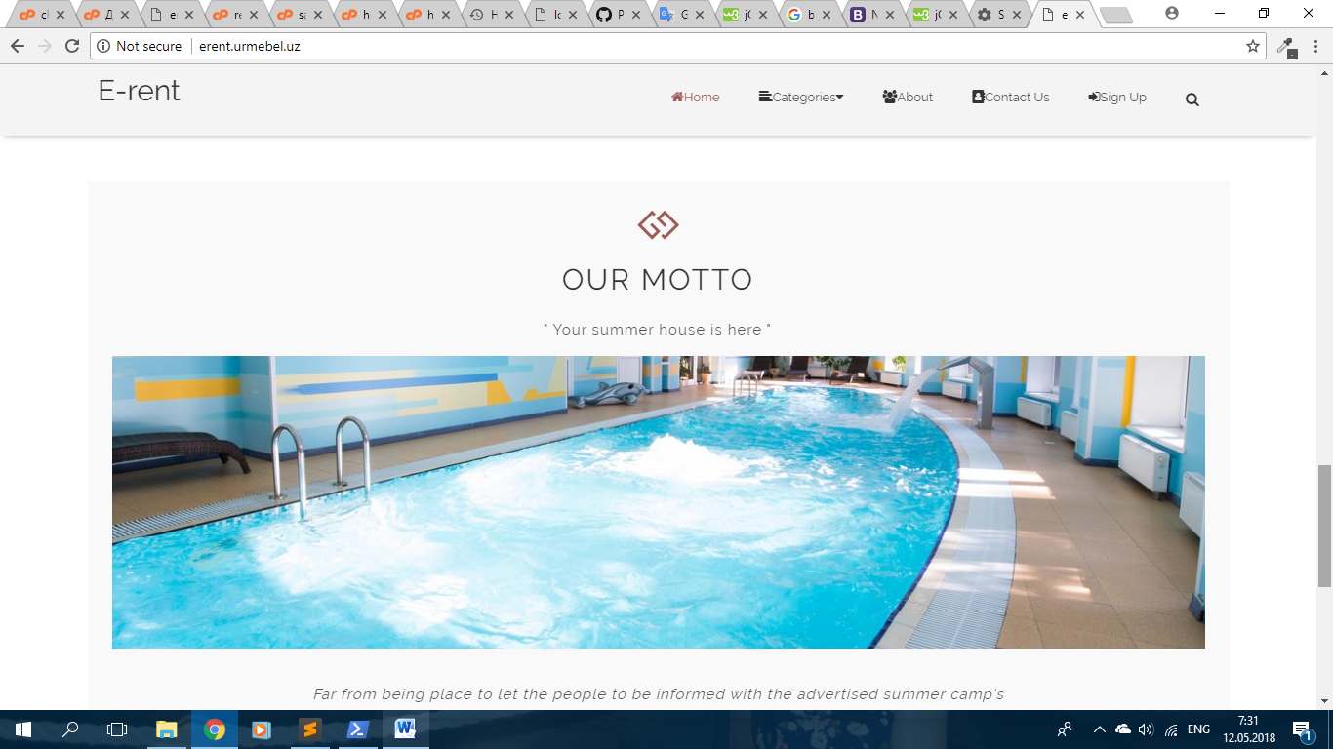

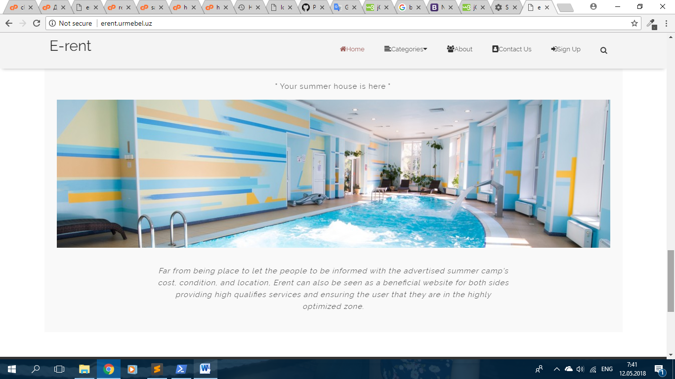

For parallax effect, I used just css styles to <div class=”parallax”>. I gave background image to this div, and make it fixed so that other divs will slide like over this image.

Finally, we came to footer part. So, I created bootstrap one main <div> with class=”row” and defined 3 <div> elements with class=”col-md-4” inside of it. In first column, there is brief information about “e-rent” company and its social network links. Then, there is a map of this company and 3rd column is contact info.

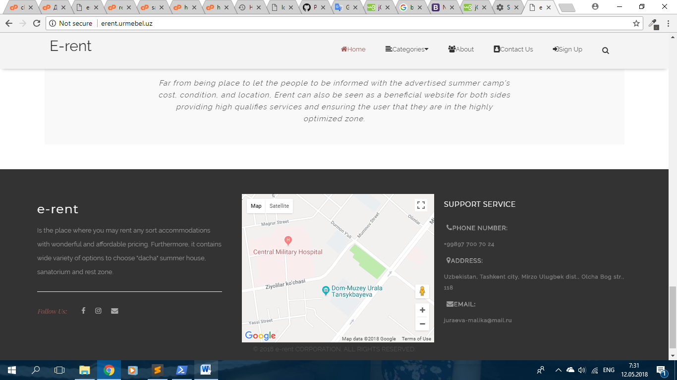

We move to the next page, called summerhouse.blade.php. In categories dropdown menu, you can see “summer cottage”, “recreational areas” and “sanatoriums”. They all built by structure of summerhouse.blade.php.

First of all you can see our logo in header part. I’ve put a sample logo(it will be changed further). I should mention that I’ve changed navbar of welcome page as far as we don’t have slide show here, but the html code is almost the same (this navigation bar got totally different classes with different styles). Here, some styles:

float:left;

background-color: #F4F4F4;

In order to make sticky navigation bar when user scrolls page, I’ve added some Jquery:

window.onscroll = function() {myFunction()};

var navbar = document.getElementById("navbar-summerhouse");

var sticky = navbar.offsetTop;

function myFunction() {

if (window.pageYOffset >= sticky) {

navbar.classList.add("sticky"); //scticky class defined in css

} else {

navbar.classList.remove("sticky");

}

}

});

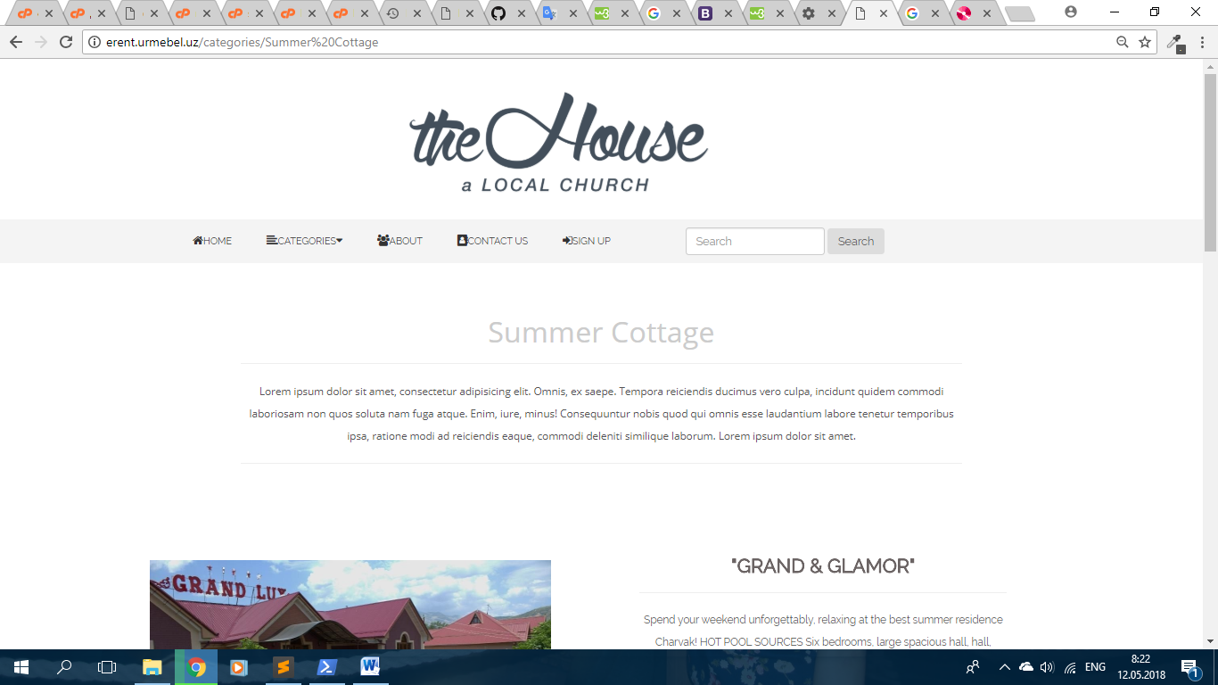

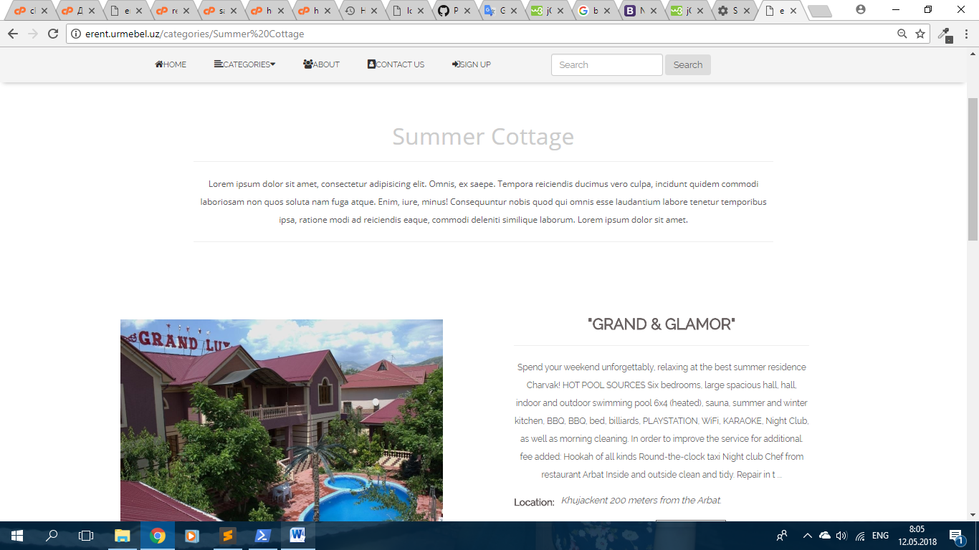

Next, some brief information about “summer cottage” and then you can see list of items. Moreover, in description part here some brief information of announcement, button for “read more”, views and rating.

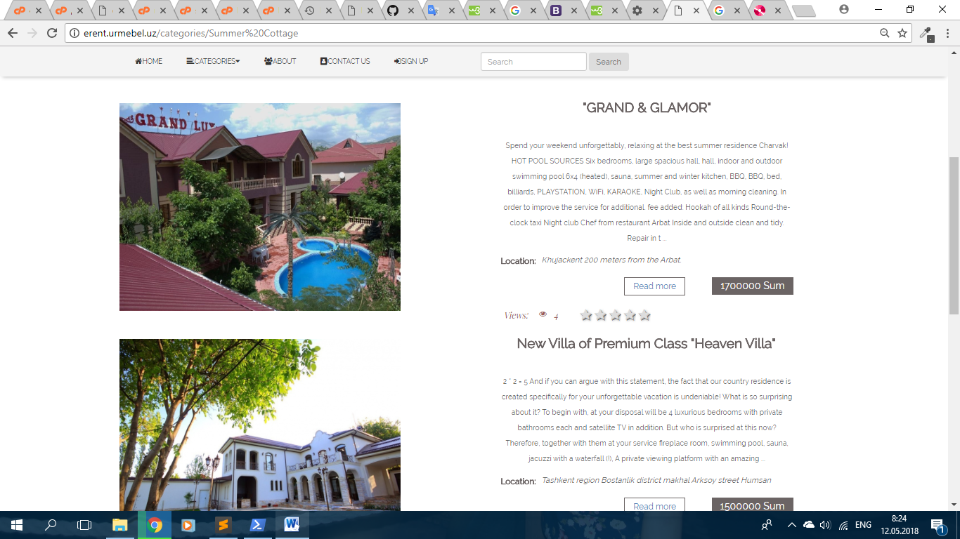

I added one footer for all web pages.

So, the next page is “about us”. Here parallax is different from one in welcome page. I’ve downloaded parallax.js file and linked to the page in order to use built in classes.

<div class="parallax-about-us" data-parallax="scroll" data-image-src=" {{asset('images/природа.jpg')}} ">

</div>

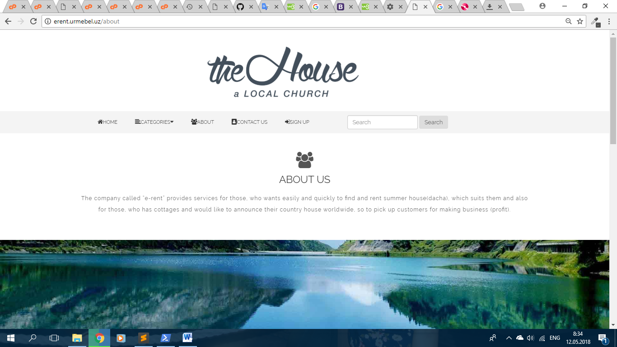

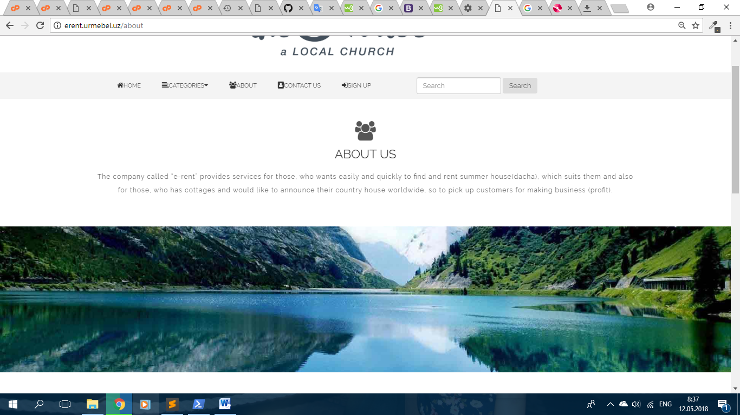

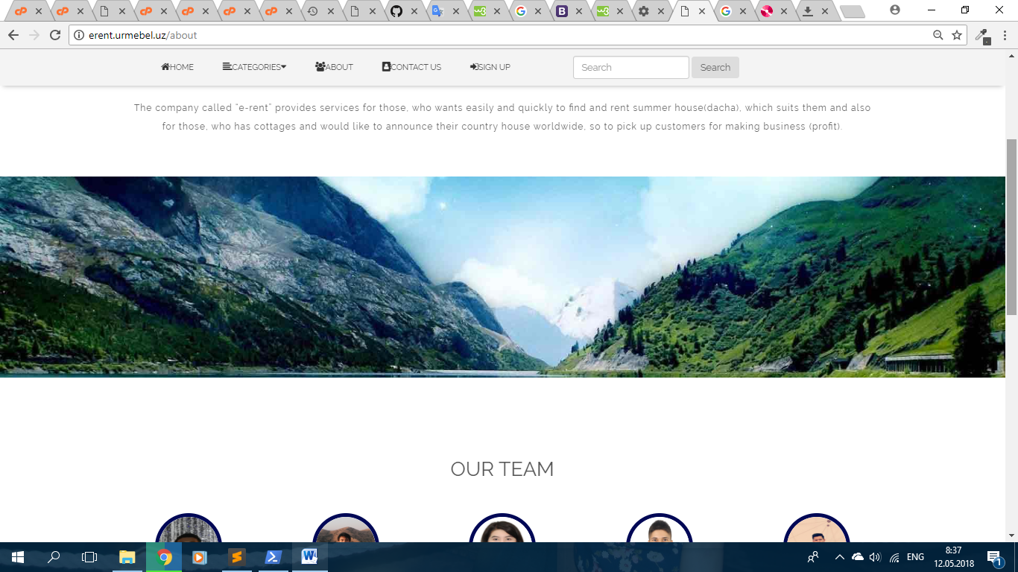

Next, I’ve introduced our team. I’ve divided into 4 “col-md-2” divs inside of “row” div.

<div class="row">

<div class="col-md-2 col-sm-3">

<div class="team-man">

<img src="…”>

</div>

<div class="team-description text-center">… </div>

</div>

</div>

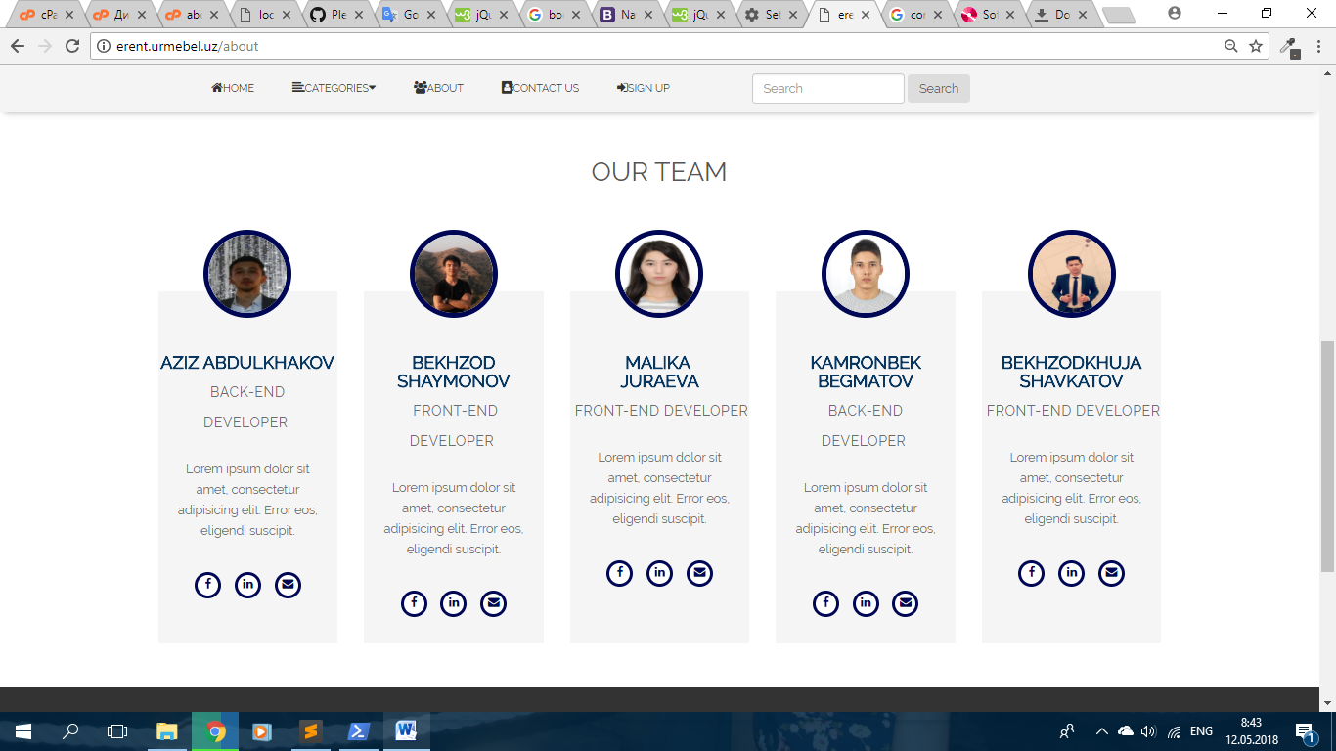

In css file, you can see all styles for title, description and icons. In addition to this, it has hover effect:

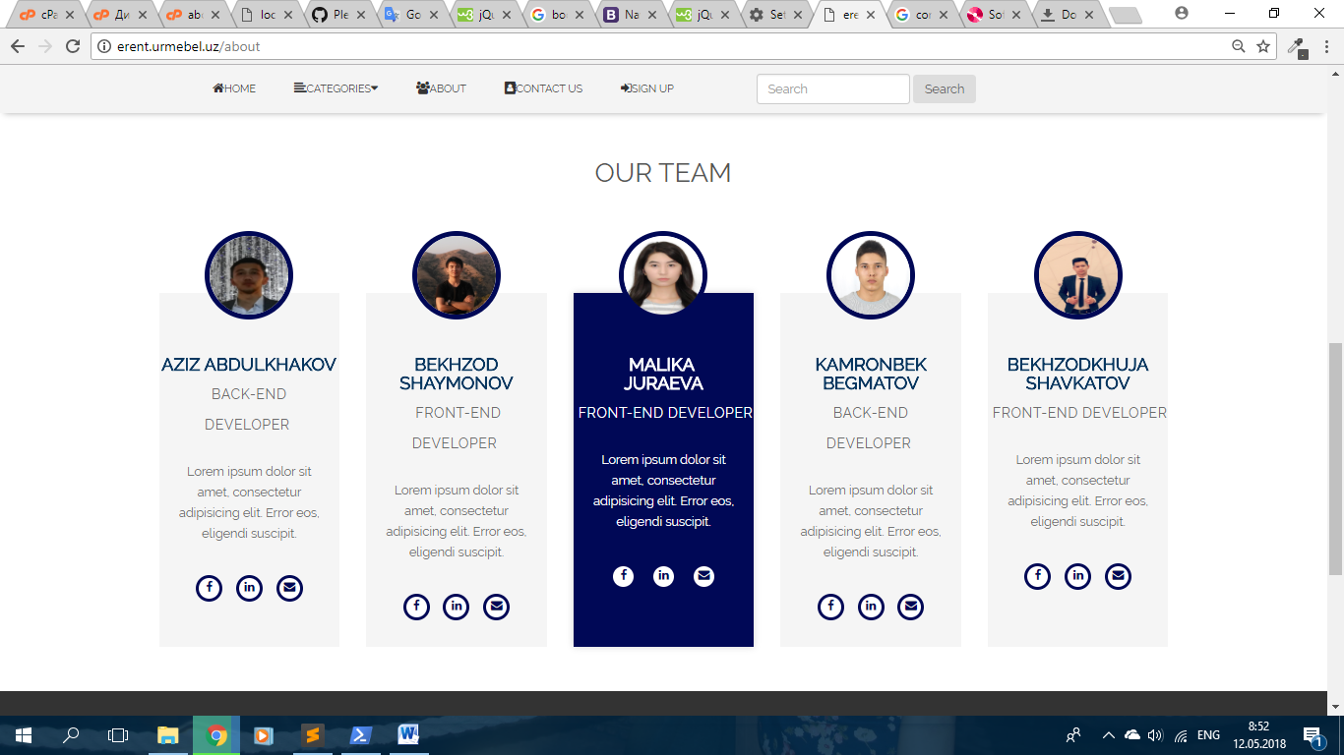

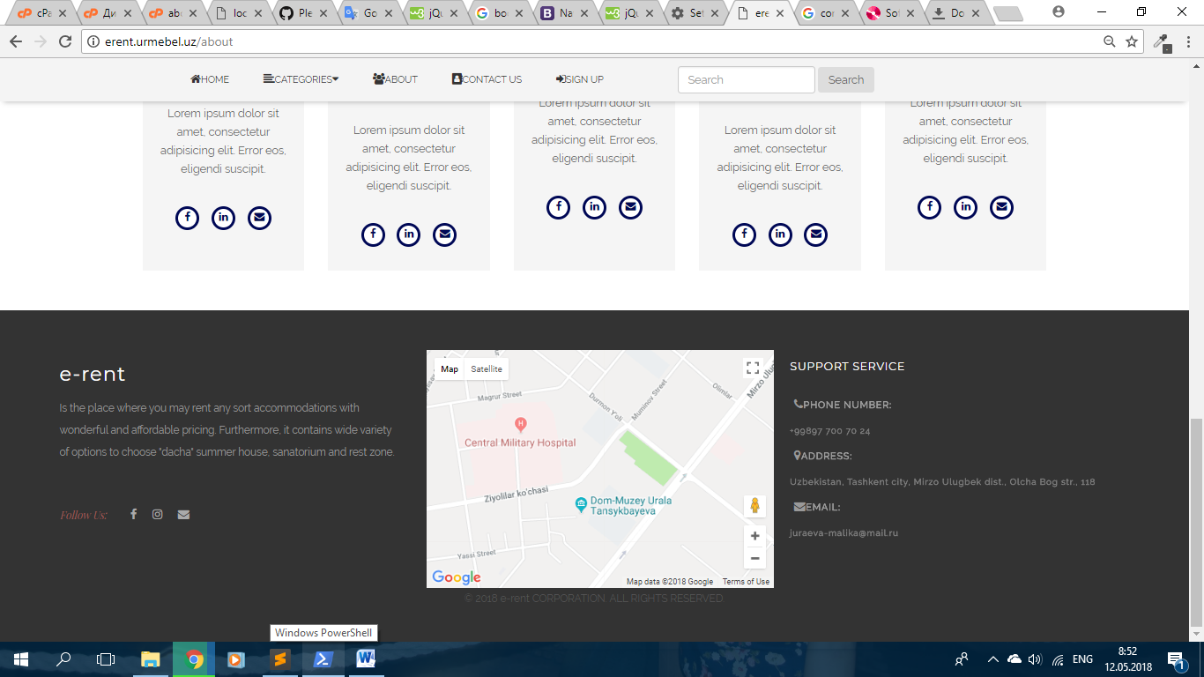

Contact us: since in background part of our form, we have a beautiful image, I used transparent navigation bar of welcome page. To look this page great, I’ve added parallax to background image ( you can see in css file). In this parallax, you can notice that contact us form and footer scrolls on image.

Contact us form built using this html structure:

<div class="col-md-4 col-2-contact-us">

<form>

<div class="form-group">

<label >… </label>

<input>

</div>

<div class="form-group">

<label >… </label>

<input>

</div>

<div class="form-group"> …</div>

<button class="btn btn-primary">Submit</button>

</form>

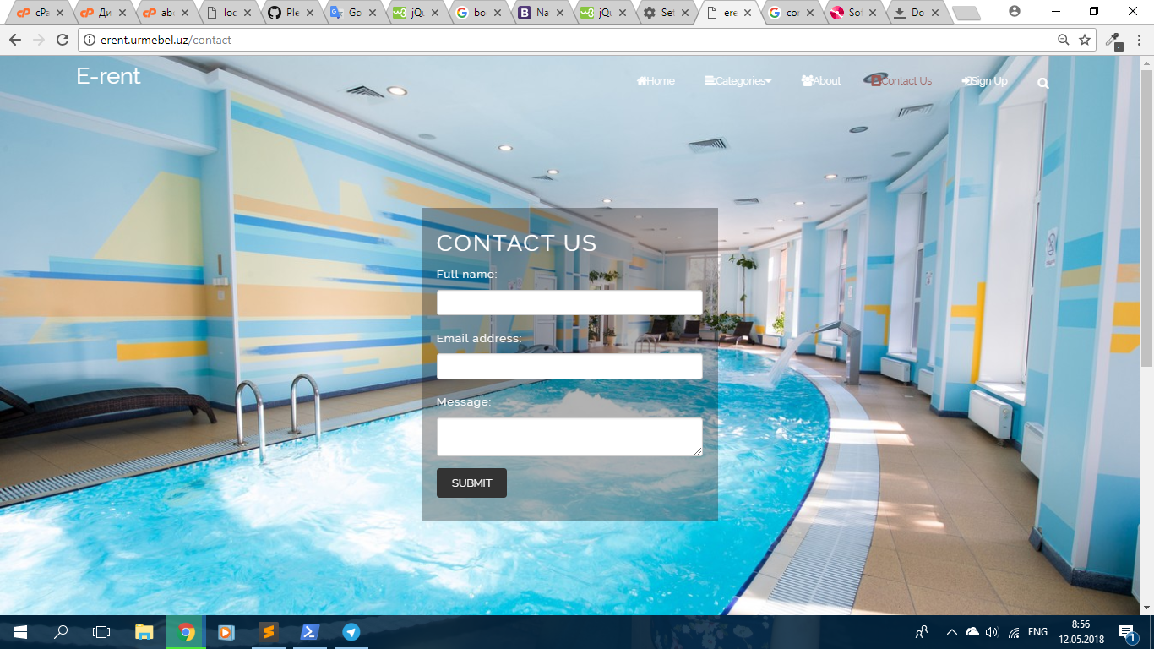

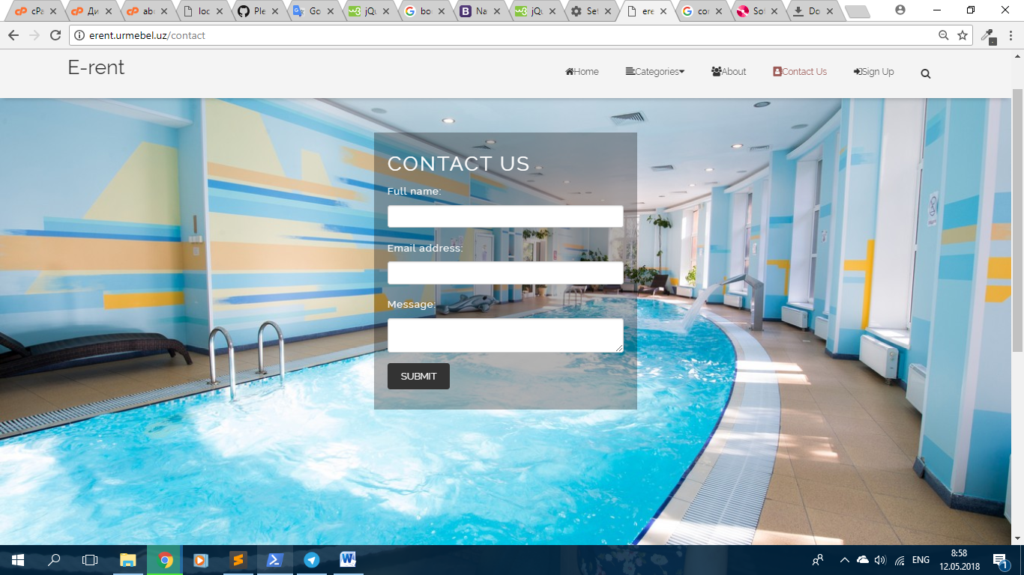

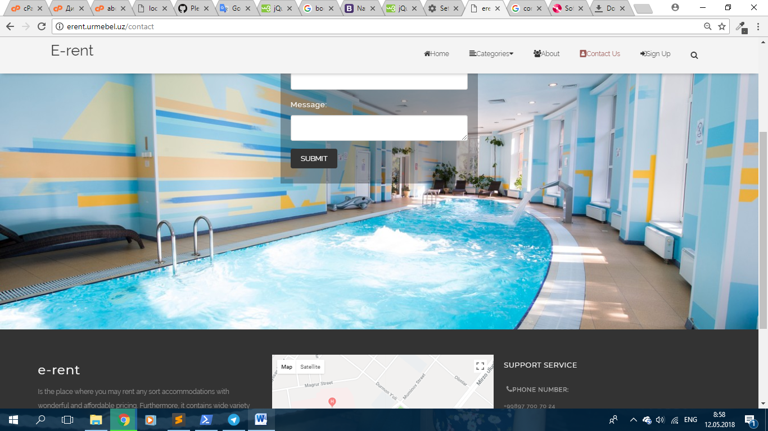

Bekhzodkhuja Shavkatov, u1610048

* Announcement page

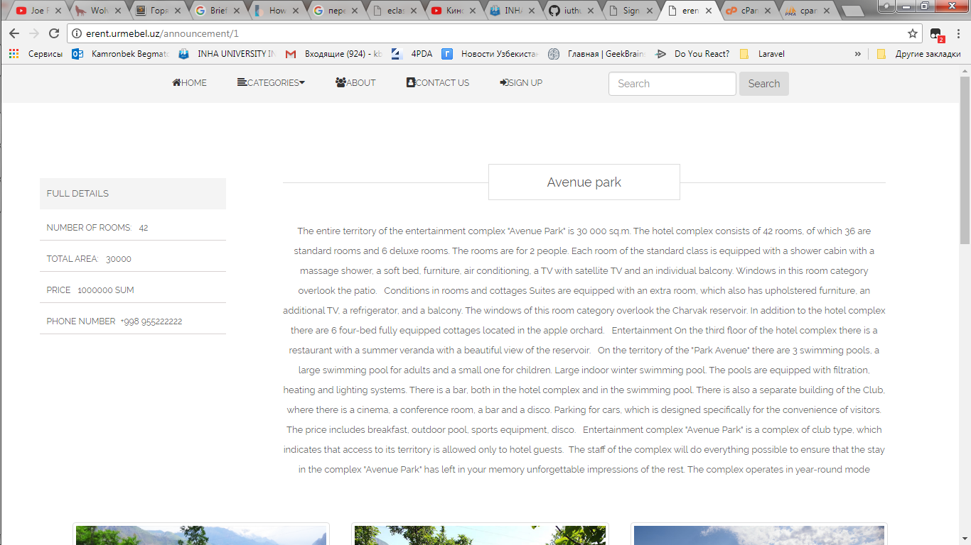

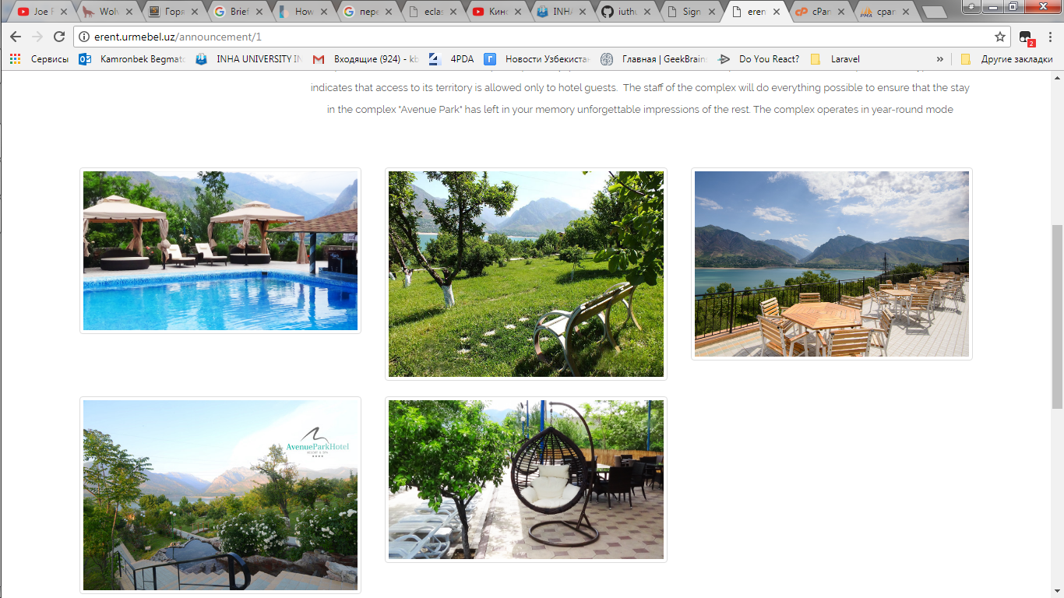

Mainly I was the content developer, duties like finding photos and relevant information. Furthermore, I supported the front end, using html and css, as you can see from above screenshots. Also I used some javascript code, to make photos bigger, when you hover the mouse over the image, so to make it better-visible:

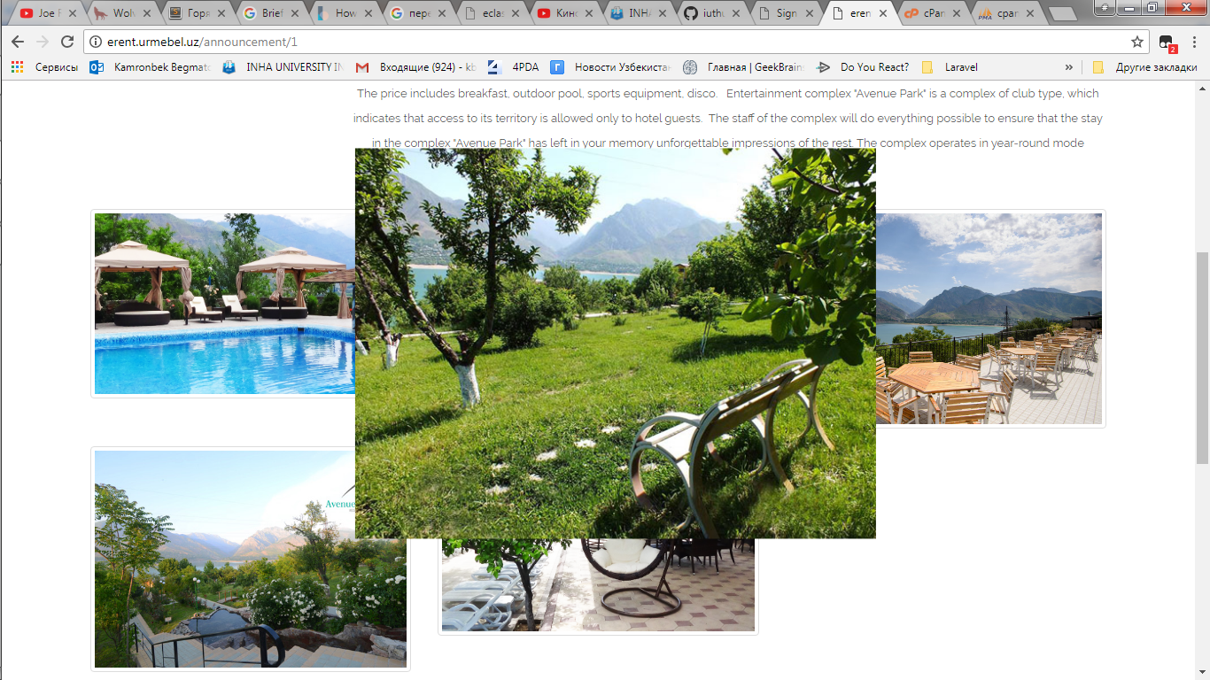

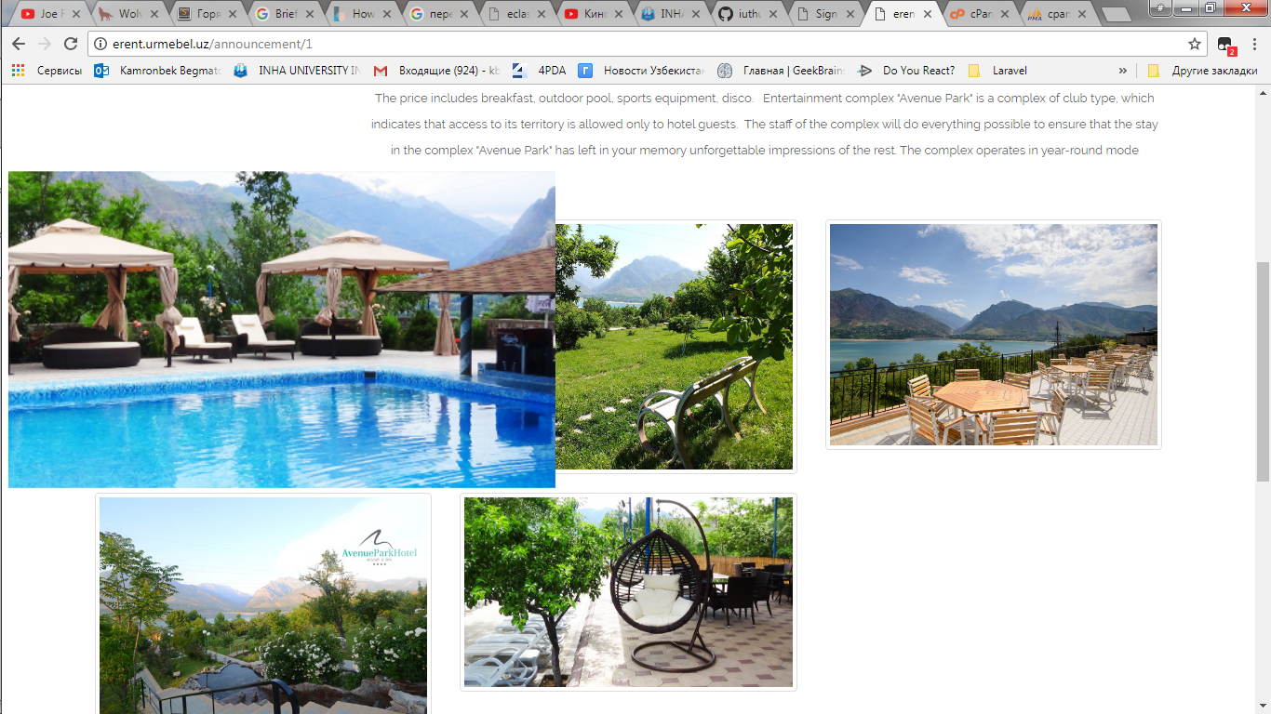

Logins and passwords for users:

L: kamr96@list.ru

P: asdfasdf

L: [b.shaymonov@student.inha.uz](mailto:b.shaymonov@student.inha.uz)

P: 5tgb6yhn7ujm

L: [bek@mail.ru](mailto:bek@mail.ru)

P: 731955